GETTING STARTED

Safety is a core value of the dairy industry 2
Hierarchy of control 3
Risk assessment matrix 4
Roles and responsibilities 5
Health and safety laws in each state 6
Workplace manslaughter laws 7
Safety factors on your farm map 8
Induction checklist 9
Safety Systems Snapshot 14
Recording hazards, incidents and injuries 17
Injury and Incident Register 20
Injury and Incident Investigation Report 21
Hazard or Near-Miss Report 23
Farm safety glossary 24

Getting started 1

SAFETY IS A CORE VALUE OF THE DAIRY INDUSTRY

Dairy farms are interesting, complex and busy workplaces. They are great places to work and they need to be safe for everyone.
Being, and feeling, safe adds a lot to the quality of the work for your staff and significantly reduces your business risk.
The dairy industry is committed to reducing the number of injuries and fatalities that occur on dairy farms.
There is an industry-wide commitment to 2030 Sustainability Goals of:
- Zero workplace fatalities on farm and in manufacturing
- 100% of dairy workers implementing good safety practices
- 30% reduction in Lost Time Injury Frequency Rate for farm and manufacturing (on figures from 2017)
We want everyone to get home safely from work every day.

Workplace safety
All workplaces have the potential to harm the people that work there. Historically, workplaces had a large number of incidents, leading to injuries and death.
Strict workplace safety laws were introduced some years ago in all states of Australia to address this. They seek
to encourage increasingly safe workplaces and carry penalties for those who fail to meet their obligations.
Workplace safety refers to the working environment at a business and encompasses all factors that impact the safety, health, and well-being of workers (where ‘workers’ means all employees, contractors, subcontractors, apprentices, trainees and owner/managers who do work on the farm).
This includes creating a safe workplace by recognising, discussing and controlling hazards and having safe working practices and processes.

Workplace health and safety laws place significant obligations on both employers and employees to maintain a safe workplace.

The resources in the Farm Safety Manual are designed to help you achieve your goals in farm safety.

Hazards, risks and controls
As the farm owner or manager you have the responsibility to ensure that hazards and risks are managed to keep everyone safe.
A hazard is something that could cause harm and a risk is the probability of a harm occurring to a person who is exposed to the hazard.
In safety terms, a control for a hazard is a way to remove the hazard or reduce the risk to a person so that harm does not happen.
Assessment of risks should happen on an on-going basis. And on a regular basis an overview assessment should happen too.
Two tools are used in safety thinking – the ‘hierarchy of control’ for determining the best means to control a
hazard and the ‘risk assessment matrix’ for assessing risks.

TIP

Not sure where to start?
Each module in the Farm Safety Manual provides specific information about an area of safety on dairy farms.
If you know which module you need to work on first, go straight there.
If you are not sure, get an overview of all areas, to help set your priorities, by doing the Quick Safety Scans (in the Farm Safety Starter Kit).

GETTING STARTED

HIERARCHY OF CONTROL

To decide the best or most practical way to reduce the risk of injury by an identified hazard, use of the ‘hierarchy of control’. This ranks the control measures from the highest level of protection to the lowest.
Firstly, try to eliminate the hazard, or if that is not possible, use a safer substitute. If this again is not practicable, consider isolation-engineering control. Next in the hierarchy is an administrative control such as a safe working procedure, often supported with training. Finally, last in the hierarchy is Personal Protective Equipment (PPE).

To step through the hierarchy of control:
- Eliminate the hazard (e.g. stop using a particular chemical)
- Substitute the hazard with a safer option (e.g. use a safer chemical)
- Use engineering and/or isolation (e.g. apply the chemical using a closed system where it is not handled)
- Set up administrative controls such as safe operation and training (e.g. have a procedure to be followed when handling the chemical)
- Use Personal Protective Equipment (PPE) (e.g. wear gloves and face shields). Note: PPE only protects the person wearing it.
Many control measures involve a combination of these steps.
Control methods at the top are more effective in protecting people from exposure to hazards. The bottom two rely on people’s actions to work safely or fit the PPE. Following this hierarchy normally leads to the implementation of inherently safer systems, where the risk of ill-health or injury can be substantially reduced.

Hierarchy of controls
Elimination
Substitution

Physically remove the hazard

BY LAW

Work health and safety regulations require that a person conducting a business or undertaking must manage risks to health and safety relating to hazards in the workplace. They must:
- Identify reasonably foreseeable hazards that could give rise to the risk
- Eliminate the risk so far as is reasonably practicable
- If it is not reasonably practicable to eliminate the risk – minimise the risk so far as is reasonably practicable by implementing control measures in accordance with the hierarchy of control
- Maintain the implemented control measure so that it remains effective
- Review, and if necessary revise, risk control measures to maintain, so far as is reasonably practicable,
a work environment that is without risks to health and safety
- Consult, so far as is reasonably practicable, with workers who are (or are likely to be) affected by the hazard.
By law, you are responsible for all the people who work or
come onto your farm, including all permanent and casual staff, contractors and visitors.

Replace the hazard

Isolate people from the hazard
Engineering Controls

Change the way people work
Administrative Controls

Protect the worker with Personal Protective Equipment
PPE

Most effective Least effective

Farm Safety Manual 2021 3

RISK ASSESSMENT MATRIX

To rate a risk which you have identified and decide on the type of control strategy that will be required, use a ‘risk assessment matrix’.
A ‘risk assessment matrix’ is a powerful tool that combines an assessment of (1) the likelihood of an incident happening and (2) the severity of the consequences of the incident, if it does occur.
The example shown below can be used for both safety and environmental risk assessments.
To step through the risk assessment process:
  - Step 1 – decide what you think is the most serious consequence that could credibly occur from exposure to the hazard
  - Step 2 – rate how likely you think that consequence is by estimating the timeframe in which it could occur

Risk Management Matrix

Risk = Consequence x Likelihood

Step 1 Select credible serious consequence that could result from exposure to the hazard
Step 2 Select Likelihood: the time in which the selected consequence could occur when exposed to the hazard

Step 2 Likelihood (of injury/incident occurring)
 |  |  | Almost Certain | Likely | Possible | Unlikely |  | Rare
 |  |  | <1 year | 1-2 years | 2-4 years | ye | 4-10  ars | >10 years
Step 1 Consequence (Most credible serious incident) | Safety | Environment
Step 1 Consequence (Most credible serious incident) | Fatality | Permanent widespread damage | 1 | 2 | 4 | 7 |  | 11
Step 1 Consequence (Most credible serious incident) | Permanent disability | Heavy damage costly restoration | 3 | 5 | 8 | 12 |  | 16
Step 1 Consequence (Most credible serious incident) | Lost Time Injury | Major but recoverable damage | 6 | 9 | 13 | 17 |  | 20
Step 1 Consequence (Most credible serious incident) | Medical treatment injury | Limited medium-term impact | 10 | 14 | 18 | 21 |  | 23
Step 1 Consequence (Most credible serious incident) | First aid injury | Short term damage | 15 | 19 | 22 | 24 |  | 25

Risk rating |  | Risk mitigation strategy | Risk review frequency
1–7 | Extreme risk | Do not proceed with task: Implement the ‘Hierarchy of Controls’, Management to be notified, Risk Register | Daily/Weekly
8–14 | High risk | Implement the ‘Hierarchy of Controls’, Management to be notified, Risk Register, Managed with high risk permits | Weekly/Monthly
15–21 | Medium risk | Implement the ‘Hierarchy of Controls’, Supervisor directly involved, managed with SOPs/SWMS/Permits, Risk Register | 3–6 months
22–25 | Low risk | Implement the ‘Hierarchy of Controls’, managed using SOPS/ SWMS, Risk Register | 6–12 months
From: Jon Temby, Axento Safety 2020

New employees can complete online modules as part of their onboarding about safety on dairy farms and their responsibilities.
See Dairy Australia’s Starting a job in dairy online modules:
enlight.dairyaustralia.com.au

There are some differences between States on how Health and Safety Representatives are elected and operate. See the website of the Regulator in your State (listed next page).
Farm Safety Manual 2021 5
GETTING STARTED

ROLES AND RESPONSIBILITIES
INTRODUCTION

The person conducting a business or undertaking has a primary duty of care to, as far as is reasonably practicable, ensure the health and safety of workers and others who may be affected by the work.
Workers also have responsibilities to take reasonable care for their own health and safety and the safety of others, and to comply and cooperate with relevant instructions.
Everyone needs to be involved to build a great safety culture on the farm.

TIP
For workers: When you are at work, you have the responsibility to take reasonable care for your own health and safety and the safety of others who might be affected by your actions. As examples, you should not take short cuts when doing your job that might put yourself or someone else at risk, or play practical jokes that could hurt someone.
You must co-operate with your employer when they are taking action to improve health and safety or to meet their legal obligations. You must follow safety policies and procedures, attend Work Health & Safety training, follow the advice you’ve been given, and use safety equipment supplied by your employer.
As an example, you must as far as you are reasonably able, wear Personal Protective Equipment (PPE), such as helmets, in accordance with the information, training and instruction you have received.

Health and safety representatives
The WH&S Act recognises that workplaces have better health and safety outcomes when workers have input before decisions are made about health and safety matters that affect them.
Part 5 of the WH&S Act allows for workers to be consulted and represented through health and safety representatives and committees: A worker may ask for a Health and Safety Representative (HSR) to be elected to represent them on work health and safety matters.
Where HSRs have been elected, the person conducting a business or undertaking must consult with them.
A Health and Safety Committee (HSC) brings together workers and management to assist in the development and review of health and safety policies and procedures for the workplace. A HSC must be established when a HSR or five or more workers makes a request to the person conducting a business or undertaking.

HEALTH AND SAFETY LAWS IN EACH STATE

Safe Work Australia is the body responsible for preparing and revising the model Work Health
and Safety Acts, regulations and codes of practice in Australia.
These models have been adopted by the Commonwealth jurisdiction and the states and territories, except Victoria and Western Australia.
Each state has its own acts, regulations and compliance codes and codes of practice.
Although some states have adopted the Safe Work Australia model, individual states continue to make amendments.
Regulating and enforcing the laws is the responsibility of the individual state and territory.
Each state has its own range of information and guidance material including that relevant to agriculture. See
the website of the regulator in your state for detailed information and resources.

New South Wales (NSW)

Act:
Work Health and Safety Act 2011 (NSW)

Regulations:
Work Health and Safety Regulation 2011 (NSW)

Codes:
NSW Codes of Practice

Regulator:
Safe Work NSW

Queensland (QLD)

Act:
Work Health and Safety Act 2011 (QLD)

Regulations:
Work Health and Safety Regulation 2011 (QLD)

Codes:
Qld Codes of Practice

Regulator:
Workplace Health and Safety Queensland

South Australia (SA)

Act:
Work Health and Safety Act 2012 (SA)

Regulations:
Work Health and Safety Regulation 2012 (SA)

Codes:
SA Codes of Practice

Regulator:
SafeWork SA

Tasmania (Tas)

Act:
Work Health and Safety Act 2012 (TAS)

Regulations:
Work Health and Safety Regulation 2012 (TAS)

Codes:
TAS Codes of Practice

Regulator:
WorkSafe Tasmania

Victoria (Vic)

Act:
Occupational Health and Safety Act 2004 (VIC)

Regulations:
Occupational Health and Safety Regulations 2007 (VIC)

Codes:
VIC Compliance Codes

Regulator:
WorkSafe Victoria

Western Australia (WA)

Act:
Occupational Safety and Health Act 1984 (WA)

Regulations:
Occupational Safety and Health Regulations 1996 (WA)

Codes:
WA Codes of Practice

Regulator:
WorkSafe WA

WORKPLACE MANSLAUGHTER LAWS

The business and personal consequences of work-related fatalities on farm significantly changed in Victoria

BY LAW

The business and personal consequences of work-related fatalities now include very large fines and jail terms.
on 1 July 2020 as new workplace manslaughter laws came into effect.
While the expectation around what happens on farm to control WHS/OHS risks has not changed, businesses and/ or individuals convicted of workplace manslaughter may now be issued large fines and even jail terms.
This brings Victoria into line with some other Australian jurisdictions (shown in green lettering below).

Workplace manslaughter laws across Australia

NT: under WHS Laws
February 2020
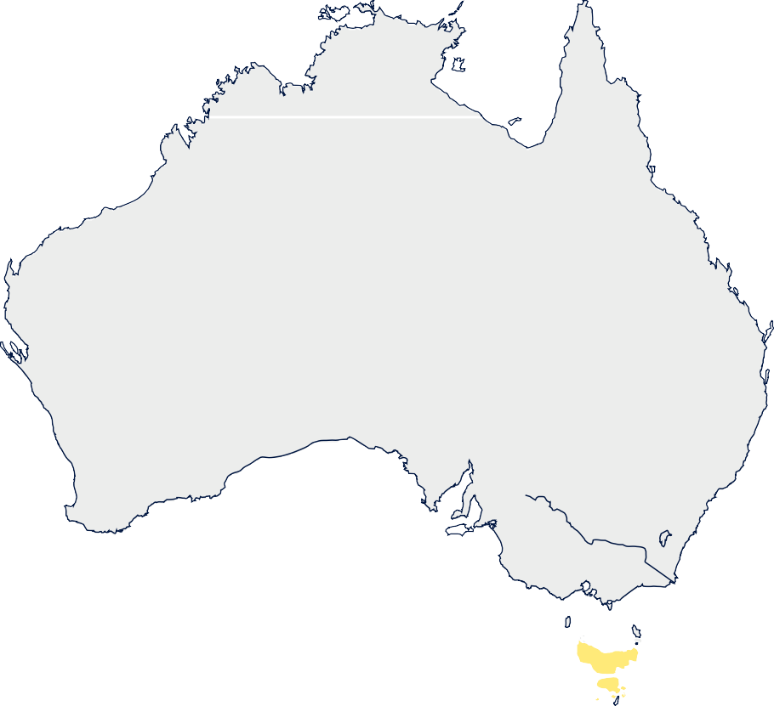

Reckless or negligent conduct causing death of an individual
    - Corporations: s~10m
    - Individuals: Life

Darwin
Qld: under WHS Laws
October 2017
PCBUs + senior officers negligently
causing death of a worker
    - Corporations: a $10m work
    - Individuals: 20 years

Western Australia

Northern Territory

Queensland

Cairns

NSW: Relying on Crimes Act general manslaughter NB: WHS Amendment (Review) Bill 2020 Expanded Cat 1 offence
to incl gross negligence

Perth

SA:
South Australia

New South Wales

Brisbane

Unlikely under
Adelaide
_{Sydney} ACT: under Crimes Act

WA:
Work Health and Safety Bill 2019 2- level industrial manslaughter offences
Crime
  - Corporations: $10m
current Govt

Vic: under OHS Act
July 2020
Tasmania
Person negligently causing

Victoria

Canberra

Melbourne
March 2004 Employers+ officers
recklessly or negligently
causing death of a worker
  - Corporations: ~$1.6m
  - Individuals: 20 years+
$300k

  - Individuals: 20 years/S5m
Simple
  - Corporations: $5m
  - Individuals: 10 years/$2.5m
death of a person* (incl. public).
  - Corporations: $16.5m
  - Individuals: 25 years
*Employees and volunteers exempt
Hobart

TAS:
Unlikely under current Govt. Labor pledged to review

SAFETY FACTORS ON YOUR FARM MAP

Dairy farm maps are used for everything from day-to-day management to
long-term strategic planning and are essential for communication with contractors and workers on the farm.
Your main map might be on the wall, but it should also be printable to include with instructions to contractors.
Key elements to include to support your safety messages and actions are:
  - Entrances for domestic vehicles, or trucks only (including milk tanker)
  - Location of major facilities e.g. houses, dairy buildings, yards, fuel tanks
  - Loading and unloading sites
  - Parking for visitors
  - Reporting point e.g. office at dairy

  - Tracks, gates and fences, crossings, bridges, paddock numbers or names
  - Dams, watercourses and effluent ponds
(include channels and drains), windmills, irrigators
  - Overhead power
(and underground if absolutely certain)
  - Any major hazards such as chemical store, wells, flooding prone areas and soaks
  - ‘No go’ zones for quads and tractors
  - Location of first aid kits and fire extinguishers
  - Emergency assembly areas
Enlargements of the areas around the dairy or main traffic areas may be required for some details.
Also include the GPS coordinates for house, dairy and/or front gate, emergency contact details and reinforcements such as speed limits and likely presence of children.

Farm map example
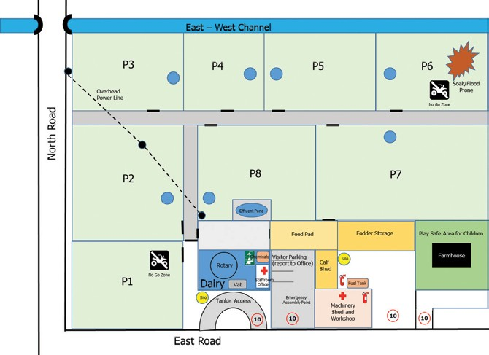

INDUCTION CHECKLIST

BE PREPARED AND PLAN THE FIRST FEW DAYS FOR EVERY NEW EMPLOYEE
The first few days on a new job can be daunting. Take the time to plan some induction activities for your new employee. Include:
- introducing them to other staff and any important clients or suppliers
- giving them the grand tour of your workplace, including Work Health and Safety and emergency procedures and exits, to make sure they know where to find everything they’ll need to do their job
- any formal or informal training, such as operating machinery
- giving them time to find their way around and settle in.
As an employer, you will need to allow adequate time for yourself or a supervisor/ manager to ensure new employees receive appropriate induction training and support, including all aspects of a workplace health and safety induction on the farm.
Staff induction activities should be designed to provide employees with the information they need to do their job effectively, enjoyably and safely.
No employee can walk into a new job and be fully effective from the first day – effectiveness grows with understanding of the farm and the details of its operation. Overall employees perform better, and are more likely to stay in the job longer, when they are clear about what is expected of them from the beginning. It is important to ensure that every employee receives appropriate induction training.
Employers and new employees starting work on a dairy farm can access a 90-day onboarding framework online in Enlight. Access the starting a job in dairy online modules here.
The 90-day journey has a series of coaching guides that provide you with a framework to safely and effectively onboard (or induct) a new employee. Access coaching resources on Enlight here.
New employees can complete online modules as part of their onboarding about safety on dairy farms and their responsibilities. This can occur before the arrive to work on the farm. Access pre-employment modules on the People in Dairy website here.

Step 1: Arrange a time with your new employee for an induction to the basics before you put them to work
The use of an induction program checklist ensures that all necessary areas are covered. Use the checklist to have everything in place before you meet with your employee and to schedule the various components, including booking time with other staff involved (e.g., the bookkeeper regarding paperwork) and various subcontractors.

Step 2: Meet and show your new employee around the farm
Induction continues until the probationary period is finished. Ask the new employee to sign the checklist after the induction program, and preferably before they start work, you will then have an acknowledgment that the employee has been shown the basics of the position.
Throughout the induction period:
- explain the Farm Policies and Systems you use
- to manage farm safety and incidents that may occur on your farm such as accidents, injuries, emergencies or discrimination;
- identify any training required;
- allow your new staff member to ask questions, particularly if they don’t fully understand something. Stress that no question is a dumb one. As an employer, you have a responsibility to be supportive;
- be supportive rather than just ‘ticking the box’ on induction.
Advice and templates regarding standard operating procedures and policies are available to help you develop your farm procedures and policies and keep necessary records of any incidents.
Visit thepeopleindairy.org.au/farm-safety
NOTE

The Farm Safety Manual complements the
Employment Starter Kit Initiative (ESKi) which contains more information about managing induction.
Visit thepeopleindairy.org.au/eski

INDUCTION CHECKLIST

Employee’s name:

Area | Action to be taken |  | Date | Initial
Introduction to the farm business  *Recommend completion on first day |  | History of the business
 |  | Goals of the business
 |  | Culture and values (code of conduct)
 |  | The team (organisational chart)
 |  | The farm map
 | Other:
Terms and conditions of employment  *Recommend completion prior to first day |  | Position description
 |  | Probationary period
 |  | Hours of work
 |  | Leave
 |  | Pay amount, method, frequency
 |  | House set up – power and phone
 |  | Training needs, plan
 | Other:
Paperwork  *Recommend completion prior to first day |  | Contract or Letter of engagement - signed and copy for both parties
Paperwork  *Recommend completion prior to first day |  | Tax declaration
Paperwork  *Recommend completion prior to first day |  | Superannuation
Paperwork  *Recommend completion prior to first day |  | Employee details form
Paperwork  *Recommend completion prior to first day |  | Proof of qualifications, work permit (if not Australian), driver’s licence, other licences such as chemical users certificate, first aid, forklift licence
Paperwork  *Recommend completion prior to first day |  | Bank account details
Paperwork  *Recommend completion prior to first day |  | Reimbursements
Paperwork  *Recommend completion prior to first day | Other:

INDUCTION CHECKLIST

Employee’s name:

Area | Action to be taken |  | Date | Initial
Rosters, applying for leave  *Recommend completion on first day |  | When rosters are available
 |  | Time recording
 |  | Reporting absences
 |  | How to apply for time off
 | Other:
Company policies  *Recommend completion in first week |  | Work clothing
Company policies  *Recommend completion in first week |  | Personal health and hygiene
Company policies  *Recommend completion in first week |  | Drug and alcohol policy
Company policies  *Recommend completion in first week |  | Anti-discrimination and harassment policy
Company policies  *Recommend completion in first week |  | Sexual harassment policy
Company policies  *Recommend completion in first week |  | Return to work policy
Company policies  *Recommend completion in first week |  | Disciplinary and grievance procedures, conflict management
Company policies  *Recommend completion in first week |  | Policy for when visitors/contractors are on the farm
Company policies  *Recommend completion in first week |  | Privacy
Company policies  *Recommend completion in first week |  | Personal visits, telephone calls etc.
Company policies  *Recommend completion in first week | Other:
OH&S procedures  *Recommend completion on first day |  | Personal protective equipment issued
OH&S procedures  *Recommend completion on first day |  | Manual handling
OH&S procedures  *Recommend completion on first day |  | Electrical safety
OH&S procedures  *Recommend completion on first day |  | Chemical safety
OH&S procedures  *Recommend completion on first day |  | Workshop safety
OH&S procedures  *Recommend completion on first day |  | Cattle handling
OH&S procedures  *Recommend completion on first day |  | Working on your own − Communications
OH&S procedures  *Recommend completion on first day |  | Hazard, injury and accident procedures and reporting
OH&S procedures  *Recommend completion on first day | Other:

INDUCTION CHECKLIST

Employee’s name:

Area | Action to be taken |  | Date | Initial
Emergency procedures  *Recommend completion on first day |  | Who to contact in an emergency
Emergency procedures  *Recommend completion on first day |  | Trained first aiders
Emergency procedures  *Recommend completion on first day |  | First aid stations/kits
Emergency procedures  *Recommend completion on first day |  | Fire safety equipment
Emergency procedures  *Recommend completion on first day |  | Emergency assembly points
Emergency procedures  *Recommend completion on first day |  | Evacuation procedure
Emergency procedures  *Recommend completion on first day | Other:
Operating machinery  *Recommend completion in first month |  | Milking machinery
Operating machinery  *Recommend completion in first month |  | Quad bike, motor bike
Operating machinery  *Recommend completion in first month |  | Chainsaw
Operating machinery  *Recommend completion in first month |  | Tractors and attachments
Operating machinery  *Recommend completion in first month | Other:
Farm tour and general information  *Recommend completion on first day |  | Dairy
 |  | Toilets and facilities
 |  | General tour, identification of hazards
 |  | Telephone answering and messages
 |  | Computer systems
 |  | Where manuals are located
 | Other:

INDUCTION CHECKLIST

Employee’s name:

Area | Action to be taken |  | Date | Initial
Work Health and Safety procedures  *Recommend completion in first week |  | Staff (their roles, responsibilities)
 |  | Supervisors
 |  | Owners, management
 |  | Other people living on the farm
 |  | Contractors, suppliers, vet
 |  | Neighbours
 |  | Local organisations, clubs
 | Other:
Introduction to the specific job tasks  *Recommend completion on first day |  | Arrangements for walk through each element of job
 |  | ‘Buddy’
 | Other:

Other comments:

Induction conducted by (name):
Date of induction:

Employee’s signature:

SAFETY SYSTEMS SNAPSHOT

The Safety Systems Snapshot provides an overview of your current farm safety system compared to Work Health and Safety legislation.
We have checked the snapshot with the Safety Regulatory Authorities who have agreed that it provides a practical guide covering the current legislation regarding safety on farms.
How to use the Safety Systems Snapshot:
It is a good idea to fill out the Snapshot with the whole farm team – however, you may decide to do it on your own.
- You will see that the Snapshot has a Traffic Light system to indicate how you rate for each step.
- There are 6 Steps to go through.
- Start with Step 1 and work across each row – either tick Red, Orange or Green for each row –that is – one tick per row.
- Work through all of the 6 Steps and 25 Rows – you will end up with 25 ticks altogether.
- If you identify areas for improvement, add them to the Action Plan.
- Revisit the Snapshot every 6−12 months to check how you have progressed – You can download another copy at thepeopleindairy.org.au/farm-safety

 | Poor practice  Each Tick in the Red Zone means you are less likely to be working safely on the farm.  Address these areas immediately! | Improving safety practice  Each Tick in the Orange Zone means you are increasing the level of safety on the farm.  There is still work to be done | Great safety practice  Each Tick in the Green Zone means you are more likely to be working safely on the farm.  Monitor and review  to continually improve
Step 1: Setting Up a Safe Workplace | No clear understanding of safety responsibilities | Safety responsibilities identified but not always understood or operating effectively | Manager and worker safety responsibilities clearly understood and acted upon
Step 1: Setting Up a Safe Workplace | No time or money allocated to meet safety responsibilities | Insufficient time and money allocated to meet safety responsibilities | Sufficient time and money allocated to meet safety responsibilities
Step 1: Setting Up a Safe Workplace | Safety not a priority | Safety not always a priority | Manager/s promote safety as a high priority
Step 1: Setting Up a Safe Workplace | No safety initiatives | Limited involvement by Manager/s in safety initiatives | Manager/s involved in all safety initiatives
Step 1: Setting Up a Safe Workplace | Manager/s set a poor safety example | Manager does not always lead by example | Manager leads by example
Step 2: Consulting (Employee Engagement) | No consultation processes in place | Consultation processes in place but not always working effectively | Agreed consultation processes are used to discuss safety issues and are working effectively
Step 2: Consulting (Employee Engagement) | Workers are not involved in safety issues | Workers are not always involved in safety decisions and developing procedures | Workers are involved in safety decisions and  developing procedures
Step 2: Consulting (Employee Engagement) | Workers views are not valued or taken into account | Workers views are not always valued and taken into account | Workers views are valued and taken into account
Step 2: Consulting (Employee Engagement) | Feedback from employees is discouraged | Feedback from employees is listened to | Feedback from employees is actively encouraged
Step 3: Managing Hazards | Tasks with safety risks not identified nor the risk controlled | Only some of the safety risks have been identified and the risks controlled | All tasks with safety risks have been identified and the risks controlled
Step 3: Managing Hazards | No safe work procedures developed | Limited development, implementation and review of safe work procedures | Safe work procedures are developed, implemented and reviewed for all these tasks
Step 3: Managing Hazards | Responsibility for doing tasks safely is left up to the worker | Safe work procedures developed but not always followed | Procedures are followed in day-to-day operations

 | Poor practice | Improving safety practice | Great safety practice
Step 4: Informing, Training and Supervising | Workers not inducted | Induction in safe work procedures occurs but is incomplete | All workers/contractors inducted and signed off for the farm
Step 4: Informing, Training and Supervising | No safety training provided | Some workers are not trained to ensure they are able to do their tasks safely | Workers are trained in safe work procedures before starting tasks
Step 4: Informing, Training and Supervising | Workers not made aware of safety issues | Workers are sometimes made aware of safety issues | Workers/Contractors are always made aware of safety issues
Step 4: Informing, Training and Supervising | Ability of workers to do tasks safely is not checked | Workers are sometimes asked to demonstrate that they can do their tasks safely | Workers are always asked to demonstrate that they can do their tasks safely
Step 4: Informing, Training and Supervising | No safety supervision | Supervision does not always result in safe work procedures being followed | Workers are supervised, where necessary, to ensure safe work procedures  are followed
Step 5: Maintaining a Safe Workplace | Safety scans are not carried out at all | Safety scans are not carried out regularly | Regular safety scans are carried out to detect hazards
Step 5: Maintaining a Safe Workplace | Workplace tools  and equipment are not maintained | Some workplace tools and equipment maintained | Workplace tools and equipment are maintained
Step 5: Maintaining a Safe Workplace | Workers not provided with easy to understand  information and training on how to do their job safely | Workers not always provided with easy to understand information and training on how to do their job safely | Workers are provided with easy to understand  information and training on how to do their job safely
Step 5: Maintaining a Safe Workplace | No process set up for reporting accidents and incidents | There is an accident/incident reporting process but it isn’t understood by all workers | There is an accident/ incident reporting process understood by all workers
Step 5: Maintaining a Safe Workplace | No emergency plans | Plans in place for some emergencies only | Plans are in place for all emergencies
Step 6: Keeping Records | Accidents/Incidents not reported | Some incidents reported, but follow-up action limited | Safety issues and incidents are reported and acted upon, including notifications required by law
Step 6: Keeping Records | No review of work practices following an incident | Safe work procedures and training not always reviewed following incident reports | Safe work procedures and training reviewed following incident reports
Step 6: Keeping Records | No records kept of training or induction | Safety training records, including induction, not up to date | Safety training records, including induction, are up to date
 | DATE REVIEWED: | REVIEWER:

RECORDING HAZARDS, INCIDENTS AND INJURIES

All injuries, accidents and incidents that occur in the workplace must be recorded and in some serious cases must also
be immediately reported to your state workplace safety authority (see section on Notifiable Incidents below).
When everyone feels positive about reporting any hazards that they see, you have a strong foundation for your farm safety program.

Best practice
- Ensure that all work-related injuries, accidents and incidents are recorded.
- Report notifiable incidents to your state workplace safety authority immediately.
- Investigate all injuries, accidents and incidents, record the findings and the follow-up.
- Ensure that hazards and near-misses are also reported and recorded.
- You must retain details of all accident and incident records for at least 5 years.

Internal reporting
You may think that the less you hear about incidents or near misses, the better. But reports of hazards or incidents should be welcomed and encouraged – they enable you to take corrective action where necessary and reduce the likelihood of future problems.
It’s essential that everyone is comfortable reporting safety or health issues to you as soon as they notice them and you are prepared to listen and act.
You don’t need an elaborate reporting system – it could just be a folder in the workshop or lunchroom – a process that everyone is encouraged to use.
When a work-related injury (minor or major) has occurred the injured person must:
  - Report the injury or illness to their supervisor or employer as soon as possible;
  - Enter the details in the injury and incident register or have another person complete the register; and
  - Obtain a Workcover medical certificate from the treating doctor, where the injury requires such treatment, and give the certificate to the employer.
All work-related injuries, accidents and incidents must be thoroughly investigated as soon as possible and controls put in place to prevent them recurring.
Employers should document all of the investigation procedure to ensure that all aspects are covered.
Once an investigation has been done it is important to follow through and implement any recommendations.
You need:
  - A way of recording hazards and near misses.
  - A register of injuries, accidents and incidents.
  - An approach for investigating injuries, accidents and incidents.

TIPS
Set up these records using the templates in this section of your Farm Safety Manual.
Make sure everyone knows where they are and how and when to fill them in.
Information and templates provided in this folder are also available at thepeopleindairy.org.au/farm-safety

TIPS
‘If you are injured at work’ poster (see next page) must be displayed in the workplace. These are available from your worker’s compensation insurer or can
be downloaded from your state work cover authority.

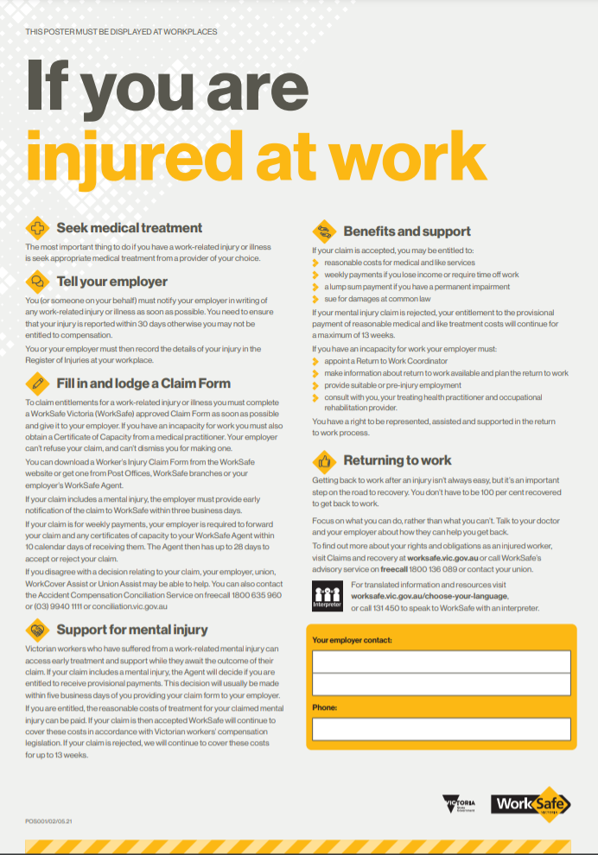

Notifiable incidents
The state workplace safety authority must be notified immediately of incidents on the farm that result in death, serious injury or impose a serious risk to health to any person.
What classifies as a notifiable incident differs from state to state but below is a summary of incidents that require notification in Victoria and New South Wales:
  - Death or serious injury to a worker;
  - Illness of a worker related to a work process;
  - Exposure to bodily fluids that presents a risk of transmission of blood-borne diseases;
  - Collapse of structure;
  - Uncontrolled escape of gas, dangerous goods or steam;
  - Overturning licensed plant and machinery;
  - Exposure to chemicals from a spill;
  - Uncontrolled explosion or fire;
  - Any incidence of violence at work.
For more details about notifiable incidents, see the Working Environment topic in this Farm Safety Manual. Failing to report a notifiable incident is an offence and penalties apply.

VIC | 13 23 60
NSW | 13 10 50
TAS | 1300 366 322
QLD | 1300 362 128
SA | 1800 777 209
WA | 1800 678 198

Recording Safety Incidents Checklist

TIPS
- The incident scene must not be disturbed until instructed by a WorkCover inspector.
- To notify the workplace safety authority in your state or if you are in doubt about your notification, phone:
Does everyone working on the farm record all hazards and near misses?
Do you have a register of all work-related injuries, accidents and incidents?
Do you investigate all injuries, accidents and incidents and keep a record of your findings and follow-up?
Do you keep your records in an accessible place for at least 5 years?

INJURY AND INCIDENT REGISTER

** Insert Manager’s name and contact details before proceeding **
Date of entry:
Name of person injured: |  | Date of birth:
Status (employee, contractor, visitor):
Address:
Signature (injured person or person reporting):
Details of injury or incident
Date of entry or incident: | Time: | am/pm
Date reported: | Time: | am/pm
Injury/incident reported to:
Injury/incident location:
Activity engaged in at time of injury incident:

Details of the injury

Cause of the injury incident:

Name of witness(es):

First aid attendant (if applicable):

First aid treatment (if applicable):

Name and address of doctor
(if applicable):

Completed by:
Notification:

Police:
Workcover Authority:

Insurer:

** File this document in the relevant farm folder and retain for five years ** Page 1 of 4

INJURY AND INCIDENT INVESTIGATION REPORT

All work-related injuries, accidents and incidents need to be investigated as soon as possible and controls put in place to prevent them recurring.
The investigation should thoroughly analyse the injury or incident, determine the cause(s) and identify actions necessary to prevent it happening again.

** Insert Manager’s name and contact details before proceeding **

Date of report: Date of incident:

Location of incident:

Investigation team

Manager or supervisor:
Employee or other person working on the farm:

Check boxes as appropriate
lost time
medical treatment

first aid
none

reported to Workcover insurance agent

Details of damage (plant/equipment/property)

Details of injury/incident

Key contributing features

Page 2 of 4

INJURY AND INCIDENT INVESTIGATION REPORT

Immediate causes

Underlying causes

Intermediate action taken to prevent further risk of injury or recurrence

Recommendations

Action and responsibilities

Completion date:

Name of manager or supervisor:

Signature:

** File this document in the relevant farm folder and retain for five years **

Page 3 of 4

HAZARD OR NEAR-MISS REPORT

To be completed by an employee or contractor reporting a hazard or near miss.

** Insert Manager’s name and contact details before proceeding **

Position: | Date: | Time: | am/pm
Reported by: |  | Position:
Signature: | Date: | Time: | am/pm

Worker/Contractor to complete
Type of incident or hazard (please tick):
Incident
Near miss

Hazard
Hazardous work practice

Location:

Description of the incident,
hazard or near miss:

Management to complete
Name of manager or supervisor:

Corrective action taken:

Further action required: Person responsible: Date to be done:

Signature: Date: Time: am/pm

** File this document in the relevant farm folder and retain for five years **

Page 4 of 4

FARM SAFETY GLOSSARY

This glossary provides easy-to-understand definitions of common workplace health and safety terms. It does not attempt to provide strict legal or technical definitions.
Act – See Work Health and Safety Act.
Administrative controls – are changes to the way people work to limit or prevent their exposure to a hazard.
Examples of administrative controls include: changes to procedures, training, installation of warning signs and labels, such as having a ‘confined space’ warning sign on a milk vat. See also Hierarchy of control.
Australian Standard (AS) – an Australian Standard published by Standards Australia, sometimes published jointly with Standards New Zealand (AS/NZS). Standards are published documents setting out specifications and procedures and are designed to ensure products, services and systems are safe, reliable and consistent. Standards are voluntary documents unless referenced by government in legislation. For more information see standards.org.au
Code of Practice (CoP) – an approved code of practice is a practical guide to achieving the standards of health, safety and welfare required by the relevant Work Health and Safety (WHS) laws. Codes do not have the same legal force as regulations.
Competent person − a person who through training, qualification or experience has acquired the knowledge and skills to carry out the task.
Consultation – the sharing of information and exchange of views on workplace health and safety matters between managers and workers or their representatives.
This may include participating in decision-making on WHS issues.
Controls – measures taken to eliminate or reduce risk to health and safety. Examples include: engineering controls, administrative controls, personal protective equipment.
A combination of these controls may be used to minimise risk, so far as reasonably practicable, if a single control is not sufficient See Hierarchy of control.
Dangerous goods – through inappropriate handling or use these substances can often result in injury
to people and/or damage to property. Examples include flammables, corrosives, and explosives, chemically reactive and oxidising chemicals.
Due diligence – taking reasonable steps to protect the health and safety of workers, including compliance with WHS duties.
Duty of care – a moral and legal obligation to look after the health and safety of people at work. Examples: employers must, as far as reasonably practicable, provide and maintain a work environment in which employees are not exposed to hazards; employees must take reasonable care for their own safety and health, and that of others at work.
Emergency plan – detailed written procedures for workers and others when responding to an emergency, such as a fire or a chemical spill. An emergency plan is necessary to keep order, and minimize the effects of the disaster.
Engineering controls – a category of risk control that uses physical/mechanical methods to eliminate or minimize the risk when exposed to a hazard. Examples of engineering controls include: ROPs on tractors, guards, barriers, exhausts, safety switches. See also Hierarchy of control.
Ergonomics – a focus on the interaction between people and the work environment by designing or arranging the workplace, equipment and work practices so they fit the people who use them.
FarmSafe organisations – independent, non- government, not-for-profit organisations (national and state based) that bring together farmers, safety and health professionals, agricultural organisations and the wider community to promote awareness and adoption of health and safety practices on farms. For example, they provide resources and run events such as Farm Safety Week. For more information see farmsafe.org.au.
First Aid – the immediate care given to a person who is injured or who suddenly becomes ill. It can range from disinfecting a cut and applying a bandage to helping someone who is choking or having a heart attack.
Guarding – use of any device or combination of devices designed to keep any part of a person’s body out of the danger zone of a machine during its operating cycle. This usually involves guarding the point of operation, guarding power transmission components by fixed enclosures, and/ or protecting the operator and nearby workers from flying fragments (an example of an engineering control).
Hazard – anything (including work practices or procedures) that has the potential to cause harm to a person.
Hazardous substance – any substance that may produce adverse health effects to people exposed to the substance (some may also be Dangerous goods)

Hierarchy of control – a method of deciding what is the best, or most practical way to reduce the risk of injury by an identified hazard. Control measures are ranked from the highest level of protection to the lowest. The hierarchy generally is firstly to eliminate the risk (e.g. stop using a particular chemical). If this is not practicable, secondly substitute (e.g. use a safer chemical). If this again is not practicable consider isolation-engineering control (e.g. chemicals are applied using a closed system where they are not handled). Next in the hierarchy is an administrative control such as a safe working procedure (e.g. procedure to be followed when handling the chemical), often supported with training. Finally last in the hierarchy is Personal Protective Equipment (PPE) which must be worn to protect the user (e.g. gloves and face shields). Many control measures involve a combination of the above.
Incident investigation – the process of systematically gathering and analysing information about an incident, to identify the causes and making recommendations to prevent the incident from occurring again.
Induction – instruction provided to workers and others on the safety and health requirements of the
workplace, including policies, practices and procedures, requirements for particular tasks and hazards that exist and the potential risks. Induction can be integrated into the broader scope of instruction about the workplace.
Inspectors – are appointed to ensure compliance
to the relevant state Work Health and Safety legislation.
They must carry identification and have the power
and right to enter any workplace and issue investigation, improvement or prohibition notices.
Job Safety Analysis (JSA) – looking at the work task to determine the safest way to complete it.
Manual handling – an activity requiring the use of force exerted by a person to lift, lower, push, pull, carry or otherwise move, hold or restrain a person, animal or thing.
Material Safety Data Sheet (MSDS) – see Safety Data Sheet (SDS).
Near miss – an incident that had the potential to cause harm but didn’t because of timely intervention (and/or chance).
Notifiable incident – an incident involving the death of a person, serious injury or illness of a person or a dangerous incident that must be notified to the state’s relevant Worksafe authority within 48 hours.
Occupational Health and Safety (OHS) – refers to ensuring the health, safety and welfare of employees and others at a workplace by prevention of accidents, injury and illness. The term Work Health and Safety (WHS) is also used.

Person Conducting a Business or Undertaking (PCBU) – a person conducting a business or undertaking,
alone or with others, whether or not for profit or gain, including as a partnership, a self-employed person, and as an unincorporated association. This phrase
also includes ‘employers’.
Personal Protective Equipment (PPE) – anything worn by a worker to reduce the risk of injury when exposed to particular hazards. Some examples are: gloves, ear
plugs, helmets, safety goggles, respirators, safety boots and sunscreen.
Plant – covers a diverse range of items from office equipment to farm machinery. Examples of plant include tractors, lifts, forklifts, hand tools, ladders and computers. Any machinery, equipment or appliance.
Practicable – a term often used in the context of ‘what is reasonably practicable?’ when deciding risk control measures. ‘Practicable’ is defined as having regard to:
  - The likelihood of a hazard or risk occurring
  - The potential seriousness of injury or harm
  - Knowledge about the hazard or risk, and ways of eliminating or reducing it
  - The availability and suitability of ways to remove or reduce the hazard or risk
  - Cost of eliminating or reducing the hazard or risk.
Regulations under the Act – these spell out specific requirements under the WHS Act and have the force of law. They set minimum requirements for specific hazards or work practices; and set requirements for registration of plant, licensing or granting of approvals or certificates.
Regulators – State, territory and commonwealth authorities that administer the relevant OHS / WHS laws under their jurisdiction. See WorkSafe authorities.
Risk – the likelihood of a worker suffering an injury or ill- health as a result of exposure to a hazard.
Risk assessment – the evaluation of the probability and consequences of injury or illness arising from exposure to an identified hazard.
Risk control – taking action to eliminate or reduce health and safety risks so far as is reasonably practicable.
Eliminating a hazard will also eliminate any risks associated with that hazard. See also Hierarchy of control.
Risk management – the process of identifying hazards, assessing the risk, putting in place control measures
and evaluating, monitoring and reviewing the outcomes.

Safe Work Australia – a national body which leads the development of policy to improve work health and safety and workers’ compensation arrangements across Australia. It has representatives from state and
Commonwealth governments, workers and employers. It does not regulate work health and safety laws.
The Commonwealth, states and territories retain responsibility for regulating and enforcing work health and safety laws in their jurisdiction. For more information see safeworkaustralia.gov.au/whs-authorities-contact- information.
Safety Data Sheet (SDS) – contains up-to-date, detailed information about specific substances including the possible health and safety hazards of
a product and how to safely store, use and handle the product. Information on first aid and personal protective equipment is also supplied.
Standard Operating Procedure (SOP) – a written instruction for a task that outlines the preferred and safest method of undertaking a task or activity based on a risk assessment and task analysis.
(Also known as a Safe Work Procedure or SWP).
Task – a set of related steps that make up a discrete part of a job. Every job is made up of a collection of tasks. For example, cupping up or applying teat spray are tasks of a milker’s job.
Task analysis – a technique used to identify, evaluate, and control health and safety hazards linked to particular tasks. A task analysis systematically breaks tasks down into their basic components. This allows each step of the process to be thoroughly evaluated. Also known as job task analysis.
Work Health and Safety (WHS) – refers to ensuring the health, safety and welfare of workers (employees
and others at a workplace) by prevention of accidents, injury and illness. The term Occupational Health and Safety (OHS) is also used.
Work Health and Safety Acts – are the laws in each state and territory that provide a legally binding framework to protect the health, safety and welfare of all workers. They also protect the health and safety of others who might be affected by the work your business does. In addition they outline fines and penalties for breaking these laws. Also see Regulations under the Act.
Workcover – compulsory insurance for employers which is funded by their contributions. It provides employers with insurance cover for the cost of benefits if their workers are injured or become ill as a result of work.
WorkSafe (or SafeWork) authorities – WorkSafe Victoria, SafeWork SA, WorkSafe WA, WorkSafe
Tasmania, SafeWork NSW, Workplace Health and Safety Queensland, WorkSafe ACT/NT WorkSafe – Usually two arms prevention and compensation. They are statutory authorities of states and territories with responsibilities to: help prevent workplace injuries occurring; enforce work health and safety laws; provide reasonably priced workplace injury insurance for employers; help injured workers back into the workforce; manage the workers’ compensation scheme. Also known as the Regulators.
Worker – includes employees, contractors, subcontractors, outworkers, apprentices and trainees, work experience students, volunteers and PCBUs if they perform work.
Workplace – any place where work is, is to be, or is likely to be, performed by a worker, self-employed person or employer.
Workplace manslaughter laws – laws in each state and territory jurisdiction on work-related fatalities. In many jurisdictions, convictions lead to large fines and even jail terms for businesses and individuals.

