STANDARD OPERATING PROCEDURE
Created: Version No:

SILAGE STACK COVERING (USING TYRES) TEMPLATE
SIlage stacks are covered with plastic specifically designed to create an anaerobic environment once weight of tyres is applied. An anaerobic environment is needed for the fermentation process to take place. Efficient fermentation is designed to create a more palatable and digestible feed which encourages dry matter intake and improves product performance. The best way to achieve this anaerobic environment is to ensure the silage stack is covered correctly and sufficient weight is applied to seal the enclosed area. Best practice is to cover the silage stack as soon as possible after the stack rolling is completed.
JOB STEPS | MEDIA | SAFETY / QUALITY / ENVIRONMENT
Covering of stack - plastic cover preparation;  Plastic for covering silage are supplied on large rolls and rolled off a dispenser or suitable platform to allow roll to move freely  Use the forklift to place the roll of silage on to the dispenser a second staff member should be used to guide the forklift/Front End Loader driver into the correct position beside the stack.  Suitable lengths of plastic are pulled off the roll to cover the width of the stack.  To achieve this task 2-3 staff members will be required to pull the plastic silage from the roll over the stack. | 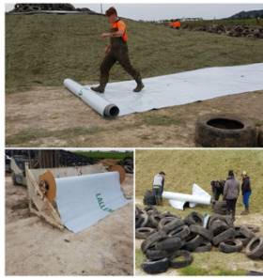 | Safety - PPE - Sturdy non slip work boots. High vis shirt, vest or jacket must be worn in the silage stack area at all times.  A silage stack angled at less than a 35 degrees allows staff to comfortably and safely walk up and down it to cover with plastic and tyres.  When loading the roll of plastic on to the dispenser, staff member guiding the forklift driver into position should keep their hands clear of the cradle holding the roll pin at all times.  If using other means of dispensing staff must be vigilant of potential crush or manual handling injuries caused by the weight of the plastic roll and bar used as the roller bar.  Forklift driver must check prior to commencing driving the forklift and be visually aware while manoeuvring of other staff members on the ground in the immediate area.  Staff members on the ground must stay clear of the forklift and roll dispenser when it is being loaded.  Quality - Approximately 1-2 metres of plastic should be left on the flat ground either side of the stack to ensure a good seal can be made once tyres are placed into position.  Ensure that plastic is not damaged in any way when dispensing as this will affect the integrity of the area of the stack leading rotting and/or poor quality silage.

Page 1 of 4
TEMPLATE 23 August 2020 Version No: 1

SILAGE STACK COVERING (USING TYRES)
SIlage stacks are covered with plastic specifically designed to create an anaerobic environment once weight of tyres is applied. An anaerobic environment is needed for the fermentation process to take place. Efficient fermentation is designed to create a more palatable and digestible feed which encourages dry matter intake and improves product performance. The best way to achieve this anaerobic environment is to ensure the silage stack is covered correctly and sufficient weight is applied to seal the enclosed area. Best practice is to cover the silage stack as soon as possible after the stack rolling is completed.
JOB STEPS | MEDIA | SAFETY / QUALITY / ENVIRONMENT
Stack covering;- Rolling out plastic  Position unfolded plastic in alignment with where it is to be pulled over the stack  2-3 staff members are to space themselves along the width of the plastic cover and grip the end of the plastic firmly in hand.  Walking in unison pull the plastic silage cover out and over the length of portion of the stack to be covered. Staff member to stand by to ensure roller is running smoothly.  Cut plastic with sharp knife/Stanely knife when desired length has been rolled out.  Positioning and unfolding plastic;  3-5 member of staff to position themselves along the length of the plastic across the stack to pull out and unfold the plastic over the potion of the stack to be covered.  Use tyres or other weights to hold areas of the plastic in position while positioning correctly. | 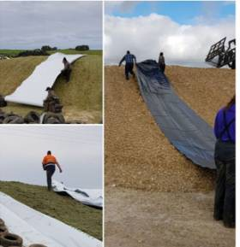 | Safety - Staff members involved in pulling the plastic up and over the stack need to move at the same pace and immediately communicate any concerns they have or if they require a short break.  Staff are to ask other their team members to slow down if they feel they can't keep up, need to regain their grip on the plastic or rest for a period.  As the plastic is being pulled over the stack ensure you have a firm footing as you walk, observing for holes or uneven surfaces on the stack as you go.  Observe wind conditions when covering the stack with plastic - do not cover in high winds as - above 30 km/hr, delay the task until conditions are more favourable.  Quality - When covering the stack with plastic, there should be a 1 meter overlap where lengths of plastic meet to ensure an airtight seal and protection from the weather once tyres are applied.  Environment - Working and communicating as a team while covering the silage stack will aid in the smooth completion of the task.
Created: 23 August 2020 Version No: 1

SILAGE STACK COVERING (USING TYRES)
SIlage stacks are covered with plastic specifically designed to create an anaerobic environment once weight of tyres is applied. An anaerobic environment is needed for the fermentation process to take place. Efficient fermentation is designed to create a more palatable and digestible feed which encourages dry matter intake and improves product performance. The best way to achieve this anaerobic environment is to ensure the silage stack is covered correctly and sufficient weight is applied to seal the enclosed area. Best practice is to cover the silage stack as soon as possible after the stack rolling is completed.
JOB STEPS | MEDIA | SAFETY / QUALITY / ENVIRONMENT
Stack Covering - Placement of Tyres.  Covering of silage stack - applying tyres;  Covering of silage stack - Move the bulk of required tyres to the top of the stack with the push rake/Front End Loader for staff to move into position.  Staff on the ground are to stay well clear of the area of the stack to which tyres are being delivered to the top until tyres have been dumped.  When staff position the tyres on the stack they are to ensure they are closely fitting and aligned in a single layer across and down the stack.  Tyres are carried up the lower part of the stack to completely cover the stack and on 1-2 metres of flat ground surrounding the silage stack.  Select larger tyres and roll them into position to hold the plastic in position on the ground immediately surrounding the base of the stack. | 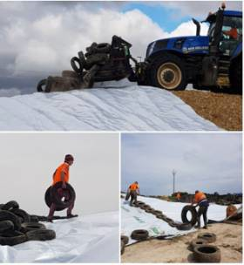 | Safety - Tractor/loader driver must ensure all staff are clear of the stack and be visually aware of where staff are when delivering tyres to the top of the stack.  Staff are to carry one tyre in each hand when walking to carry tyres in to position. Where possible roll tyres into position.  Staff must seek advice or stop working and alert management if they feel they are unable to physically complete the task.  Only carry two tyres at a time, one in each hand when walking the silage stack to place the tyres. Choose two tyres that look like they are of similar size and weight so you can spread the load evenly when transferring them.  Staff are to remain clear of the stack while the tractor driver delivers the tyres to the top of the stack as tyres have the potential to roll down the stack at speed creating a potential crush high impact hazard.  Quality - Tractor delivering tyres to the top of the stack must only drive on uncovered areas. Driving over the plastic will split or damage the integrity of the plastic.  Note in the process of walking tyres down the stack downward tension is placed on the plastic giving the stack a tighter air seal for effective anaerobic environment.
Created: 23 August 2020 Version No: 1

SILAGE STACK COVERING (USING TYRES)
SIlage stacks are covered with plastic specifically designed to create an anaerobic environment once weight of tyres is applied. An anaerobic environment is needed for the fermentation process to take place. Efficient fermentation is designed to create a more palatable and digestible feed which encourages dry matter intake and improves product performance. The best way to achieve this anaerobic environment is to ensure the silage stack is covered correctly and sufficient weight is applied to seal the enclosed area. Best practice is to cover the silage stack as soon as possible after the stack rolling is completed.
JOB STEPS | MEDIA | SAFETY / QUALITY / ENVIRONMENT
Manual handling of tyres when covering the silage stack;  Ensure Manual Handling guidelines are followed when carrying tyres to cover the silage stack.  Cover as much as the stack as possible carrying tyres that have been placed on top of the stack down and in to position.  When selecting tyres discard any tyres that have protruding wire or have perished to the extent that they no longer are of any benefit as a weight on the plastic on the stack.  Place all tyres not fit for purpose | 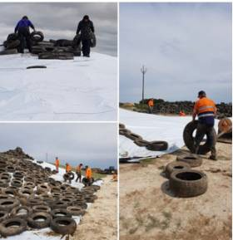 | Safety - Correct manual handling techniques as per ( farm name) Manual Handling Policy must be used including;  - Lifting tyres in both hands to maintain spread the load and maintain balance.  - Bending at the knees and keeping your back straight when lifting tyres.  - Never twisting from the back, always move your feet to turn.  Only lift weight that you feel capable of doing.  Report any signs or symptoms of discomfort so the risk can be managed before an injury occurs.  The team leader of the task must ensure short rest breaks are taken regularly during the process of covering the silage stack.  In warm weather ensure drinking water is on hand to maintain hydration.  Quality - Walking tyres down the stack aids in creating and tightening effect on the plastic as the weight of the tyres is placed.  Environment - Tyres no longer fit for purpose need to be disposed of correctly as they have the potential to cause injury through exposed wire and they are no longer beneficial in the weighing down plastic.
Created: 23 August 2020 Version No: 1

