VISITORS, CHILDREN AND TRAFFIC

Step-by-step – Setting up safety for 3
visitors, children and traffic on your farm
Self assessment – Add your actions to 4
your Action Plan at the back of this folder
Visitors 5
Children on farms 6
(including visitors’ children)
Fencing and safe play areas 9
Water and children 10
Traffic 14
Farm policy on children in the workplace 16
Dairy safety induction for visitors 18

Farm Safety Manual 2021 1

Everyone wants a safe place to live and work. The challenge with dairy farms is that they are workplaces with potentially hazardous animals, equipment, environments and substances and they are also places where families live and invite visitors. Children living on and visiting farms can be exposed to a variety of workplace hazards not present at most homes.
All farm businesses have an obligation under law to provide a safe and healthy workplace for their employees, contractors, family, visitors and members of the public.
Farm businesses who don’t act to fulfil health and safety responsibilities face significant fines and penalties. Not to mention the heartache of knowing someone has been injured or killed.

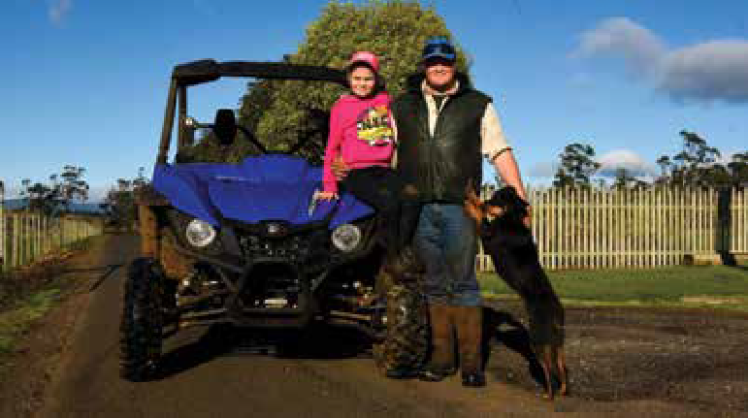From The Advocate 19 July, 2017

Farm Safety Week 2017: Safety is everyone’s business at Ashgrove
SARAH LANSDOWN

On a dairy farm, hazards are everywhere you look: from electric fences to unseen holes in the paddock.
Ashgrove Dairy was recognised as an industry leader in farm safety when they took out
the Dairy Safety Award at the annual Tasmanian Dairy Awards.
Operations manager at Ashgrove Farms Troy Ainslie said the company was happy to win the award, which was jointly

Safe and sound: Ashgrove Farms operations manager, Troy Ainslie, and his daughter Indianna, 8, and dog Bazz. Picture: Neil Richardson

presented by the Tasmanian Institute of Agriculture (TIA) and DairyTas.
“We were stoked. We were real happy about it to know that
it was recognised, what we’re doing for our employees,” Mr Ainslie said.
The award recognises farms that show initiative and innovation to improve safety at their business.
At Ashgrove, managing risks starts before you even step foot on the farm.
“We do have some big signs out front of the farms listing majority of hazards on the farm and not allowed in until you’ve contacted number on the board,” Mr Ainslie said.
Employee training was also a large part of mitigating accidents on the farm.
Mr Ainslie said he strove to create a friendly, happy workplace and that he delegated tasks according to different employees’ skills.
Mr Ainslie manages 13 staff at Ashgrove farms with experience levels ranging from one week to 10 years.

“Every employee contributes towards it and it’s every employee’s
business,” Mr Ainslie.

VISITORS, CHILDREN AND TRAFFIC

STEP-BY-STEP – SETTING UP SAFETY FOR VISITORS, CHILDREN AND TRAFFIC ON YOUR FARM

Resources in this section
Getting started

Read through this information pack.

Complete the visitors, children and traffic
Safety Self-Assessment (traffic lights) page.

Make a list of things to do and set a date to have each thing completed in the Action Plan.

Read through the information quickly again.

Pick a topic to discuss with staff or family at your next workplace meeting (you should have at least one safety topic each meeting).
- Information about safety for visitors, children and traffic on dairy farms and legal obligations

Safety Self-Assessment
- Templates
  - Induction for visitors
  - Policy around bringing children on farm
Information and templates provided in this folder are also available at thepeopleindairy.org.au/farm-safety
You can edit the templates to suit your farm.

SELF ASSESSMENT – ADD YOUR ACTIONS TO YOUR ACTION PLAN AT THE BACK OF THIS FOLDER

For visitors, children and traffic | Poor practice  Address these areas immediately! | Improving safety practice  There is still work to be done | Great  safety practice  Monitor and review  to continually improve
A traffic management plan that separates vehicles and pedestrians, especially near the dairy | Not in place | Some elements in place | Fully implemented
Truck entrance to the farm | Same as to the house | Near the house, some shared track | Separate from the house
Operational reverse warning beepers and rotational beacons on mobile plant | None | Some | All mobile plant
Parking for workers and visitors away from hazardous areas | None designated | Designated but not signed | Designated and clearly signed
Reporting on arrival by visitors and their induction on safety rules | Not done | Sometimes | Always
Workers and others wear high visibility clothing | Rarely | Sometimes | At all times
Rules: ‘No go’ zones, speed limits | Not established | Usually followed, but not always | Always followed
Rules: No children under 16 years to operate Quads/no riding on vehicle trays or trailers/no passengers on quads or mobile plant | Not established or followed | Usually followed, but not always | Always followed
Rules: Seat belts for all vehicle operators and passengers/child restraints for under 7-year-olds | Not clear or followed | Usually followed, but not always | Always followed
Toddler-proof fencing and safe play area near the house | Not in place | In place but needs improving | Well set up
Hazardous areas such as chemical stores, water, workshops, ladders | Could be accessed by children | Most secured but not all | All secured,  no access possible
Policy: workers and visitors not to bring children onto the farm without permission | Not established or followed | Usually followed, but not always | Always followed
Supervision of children when on the farm | Rarely | Sometimes | At all times
Reporting accidents and incidents | No process set up | Process set up, not used by all | Process is used by all workers
Follow-up of reported incidents | None | Limited review and action | All issues acted on

VISITORS, CHILDREN AND TRAFFIC

VISITORS

Visitors are a welcome part of business and family life on farms, but it is important that all visitors know and co-operate
with the farm’s health and safety rules.
Visitors should report to the manager or nominated person when they arrive and receive an induction briefing on the relevant aspects of the farm – such as layout,
no-go zones and activities, specific hazards, emergency procedures, hazard and incident reporting. It may be important to discuss any clothing or protective equipment needed. This is also a time to make the farm policy on children clear.
Use the template to construct your own process for induction of visitors.
Best practice
- Provide clear directional signage for parking and reporting on arrival
- Provide an induction for visitors that includes the safety rules of the farm and no-go areas
- Establish a policy around children in the workplace, including those of visitors
- Ensure visitors’ children are supervised if entering a work area
- Ensure that access to hazardous areas is restricted and appropriately signed

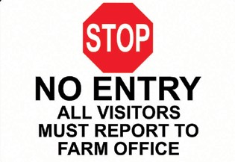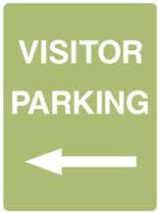
Clear directions for visitors enhance farm safety (and biosecurity)

CHILDREN ON FARMS (INCLUDING VISITORS’ CHILDREN)

Farms are great places to grow up and develop independence and skills and this is especially so if it happens in a strong culture of caring about safety.
Every area of the farm poses risks for children. This is true for those who live on the farm, including tenants’ children, and those who visit the farm (around 30% of children
who die on farms are visitors). Chemicals, water, heights, vehicles, workshops and livestock are all hazards that can cause serious injuries for kids.
The most common causes of fatalities and injuries to children on farms are:
- Drowning of toddlers
- Falling off or being crushed by Quad bikes
- Runovers by tractors and farm vehicles
- Falling off the back off moving farm utes
- Farm vehicle crashes
- Entanglement in farm machinery
- Being crushed by livestock
Many of the topics in your Farm Safety Manual have covered these areas in detail, particularly in Water and Effluent, Quads and Motorbikes, Farm Vehicles, and the section on Traffic in this topic. Think about children as you use these resources.
It is wise to have a policy around workers bringing children to work. The safest option is for no children of workers
to be present but if children are allowed it should only happen with permission and there should be clear rules about where they are permitted to be, what they can and cannot do, and the supervision required.
The positive message of getting it right (“this is what we expect” via a code of conduct or statement of policies/protocols) must be underpinned by making the consequences of not doing it very clear (i.e. a zero- tolerance disciplinary procedure). Use the template in this topic to draft a policy for your farm, then discuss and develop it with your staff. If they contribute to the final version of the policy it is more likely to be workable and followed.
The following is a summary of best practice suggestions to reducing the risk of fatalities and injuries to children on farms, as supported by Farmsafe Australia and Kidsafe Australia.
Best practice
- Create a Safe Play Area for toddlers
- Supervise children on farms
- Remove keys from vehicles, Quads and tractors
- Do not allow children under 16 years of age to operate Quads
- Do not carry children as passengers on tractors, farm machinery or Quads
- Do not allow children to ride in the back of utes, side- by-sides or trailers
- Ensure that children wear seat belts inside farm vehicles
- Ensure that everyone wears helmets when riding horses, bicycles,motorbikes and for Quads and side- by-sides for children 16 years of age and older.
The list of reminders and recommendations below is not exhaustive, but provides a guide. A walk-through by parents, grandparents, older children and others will help to identify hazards that need to be addressed on each farm.

LEARN MORE

FarmSafe
farmsafe.org.au/content/product/Child%20 Safety%20%26%20Teaching%20Kits/
Guidance Booklet
aghealth.sydney.edu.au/wp-content/ uploads/2019/05/Child_Safety_on_Farms.pdf
Better Health
betterhealth.vic.gov.au/health/healthyliving/farm- safety-children#farm-risk-assessment-children

VISITORS, CHILDREN AND TRAFFIC

Around water, including effluent ponds, wells, irrigation channels and dams
- Provide young children with safe play areas that are escape-proof
- Fence around houses to restrict (and define boundaries) for children
- Fence off swimming pools
- Where practical, fence off dams, effluent ponds and solids traps near houses
- Fit secure covers to wells, drains and tanks
- Fill in holes, ditches and post holes that fill with water (and check if there are containers that may fill with water after heavy rain)
- Inform workers and visitors (include house renters and farm stay tenants) of the water hazards present on the farm
- Fit reminder signage to close gates around safe play areas, around house yards and around fenced off water hazards
- Fit signage warning of relevant water hazards
- Ensure adult supervision of children when in, on or around water. Never take your eyes off children around water.
- Have children undertake a water awareness program
- Have workers and others undertake CPR training
- Establish emergency response procedures

Quads
- Do not allow children under 16 to operate Quads
- Do not carry passengers, including children, on Quads

Motorbikes
- Match the motorbike size and power to child’s size, strength and judgement
- Consider power governors/speed restrictors
- Establish rules around speed, ‘no go’ zones and no passengers
- Provide instruction in controls and correct riding techniques, including varying terrain and surfaces
- Insist that the child wears a correct fitting motorcycle helmet (AS 1698)

TIPS

Is it the right sized motorbike for the child?
- Can the child lift the bike from the ground unassisted? and
- Can the child reach the ground with their feet when astride the bike?

Livestock
- Provide clear direction to visitors regarding ‘no go’ zones on the farm
- Always supervise young children around animals (including calves and dogs)
- Ensure there are physical barriers between them and any animal
- Locate bulls in secure paddocks away from the house
- If they are riding horses on the farm, match the horse to the child’s experience and confidence
- Ensure riders wear a correct fitting helmet (that meets AS 3838 Equestrian helmet) and riding boots
- Teach children to wash their hands after touching animals

Tractors, farm vehicles and farm machinery
- Fit warning devices and reversing cameras 29 Dress children with highly visible clothing
- Establish rules for operators and children including:
  - Do not leave tractors, vehicles and machinery running unattended
  - Remove keys and lock cabins
  - Reverse park into sheds to ensure clear vision when exiting
  - No children as passengers on tractors or farm machinery
  - Do not allow play on tractors and machinery
  - Lower all raised implements (including loader and forks) after use
  - Explain hazards associated with tractors and machinery to children
  - No riding on trays of utes or trailers
  - Use child restraints and seat belts at all times (and set the example)

Farm workshop and machinery maintenance shed
- Have lockable doors to isolate whole area 32 Return all tools to storage after use
- Ensure Safety switches cover all power outlets
- Ensure all portable electric tools are turned off and disconnected
- Maintain guards on equipment such as air compressors and small engine belt drives
- Ensure chemicals are stored in locked suitable storage facilities.

The dairy and feed areas

LEARN MORE

Child care options for farm families
sydney.edu.au/medicine/aghealth/uploaded/ Child%20Safety%20Resources/childcare_report.pdf
Children in the workplace
commerce.wa.gov.au/sites/default/files/atoms/files/ children_at_the_workplace.pdf
worksafe.vic.gov.au/resources/keeping-children- safe-workplace-handbook-workplaces
- Ensure that hot water taps are clearly marked (red) and out of reach of children and/or locked off
- Return chemicals to secure and locked storage
- Isolate chemicals in use, contain spills within the isolated area, and ensure all are out of reach of child hands and fingers
- Store refrigerated chemicals in a separate lockable fridge
- Never decant chemicals into drink or water bottles
- Teach children not to touch, smell or drink chemicals 43 Ensure that all plant is guarded (with attention to
automated equipment) and isolate with physical barriers if not able to be guarded
- Fit child-proof guards or cut off ladder access on silos and tanks

LEARN MORE

Children helping out
Children are always keen to help on the farm but chores or jobs should be matched to their physical, mental and emotional development.
Child Safety on Farms is an excellent guide to understanding child development and capability at different ages, and gives practical tips about educating children about safety.
sydney.edu.au/medicine/aghealth/uploaded/fs_ docs/guidance/Child_Safety_on_Farms.pdf
- Guard feed plant including augers, crushers and rollers 46 Isolate feed processing sheds
- Fence off and secure hay and silage stacks (routinely inspect stability of stacks)
- Instruct children not to play on hay stacks or on bulk feed bunkers
- Store firearms in a compliant gun safe
- Consider secure, visible child area within the office area of the dairy
- Supervise all children visiting the dairy

TIP

Be a role model. Kids are quick to pick up the difference between what we say and what we do. Building a safety culture on the farm is about being clear and consistent all the time.

VISITORS, CHILDREN AND TRAFFIC

FENCING AND SAFE PLAY AREAS

Where fences are used to restrict children’s access to hazards (such as dams, effluent ponds or vehicle tracks) or demonstrate boundaries (such as around the house) choosing the fencing materials is important. Well-strained chicken wire is a good option because it is more difficult to climb than plain wire, ring lock or hinge joint fences.

TIP

The fence of the child safe play area should be made of materials that are sturdy and are not easily climbable by children. There should be no gap greater than 100mm between the fence and the ground and it should be high enough to prevent children climbing over it (without anything nearby that can be climbed on like pots, BBQs, chairs or vegetation).
The gate to the child safe play area should be
self-closing and self-latching and should never be propped open under any circumstances. Fences and gates should be regularly maintained to ensure they are always in good working order.
Child safe play areas do not replace active adult supervision and should be in an area that is easily observable by parents and carers.
Farms with young children living or visiting should also have a Safe Play Area. This is a securely fenced area which can be used by toddlers in safety, in general use or in the event of an emergency. It might be a smaller area within the house yard, which can be dismantled once the children have grown.
The Safe Play Area It should be securely fenced, without any water bodies or drowning hazards inside it, and with toys and equipment to make it a fun place for young children to be.

LEARN MORE

For ideas about play safe areas from farming families see:
aghealth.sydney.edu.au/wp-content/ uploads/2019/05/aghealth_spa_booklet.pdf

WATER AND CHILDREN

In a research project funded by the Rural Industries Research and Development Corporation (RIRDC), a range of fence designs were collected from farmers, fencing manufacturers and contractors and assessed by an expert panel to provide guidance on the pros and cons of each design. Four examples from this study are shown here:

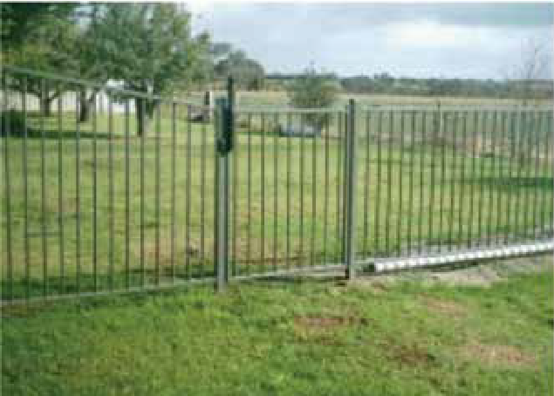
Example 1
- The most cost effective pool compliant fencing of this type consists of vertical members that are either 8mm wire, or round/rectangle hollow section steel.
- The distance between vertical members is usually 80–90mm.
The distance between the farthest apart horizontal supports is a minimum of 900mm, which makes it difficult for a child to scale this fence.
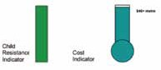

Comments against key criteria
1 | Effectiveness as a child resistant barrier | - These fence designs are pool fence compliant, and are therefore considered to be highly child resistant.
2 | Potential to injure a child attempting to scale the fence | - Risk of injury is low.
3 | Robustness, corrosion and wear resistance | - This product is hot dip galvanised, and is therefore long lasting.
4 | Material cost and availability | - Cost is over $60 per metre for materials only.  - There are standard pool fencing designs, which are widely available.
5 | Ease of installation, maintenance requirements | - Installation is straight forward, with low maintenance requirements.
6 | Aesthetics and potential to customise. | - This product is typically powder coated, with a range of colours and decorative upper styles available.

These designs offer a highly child resistant fence.
- If this type of fencing is considered too expensive for large area, a smaller play area could be considered.

VISITORS, CHILDREN AND TRAFFIC

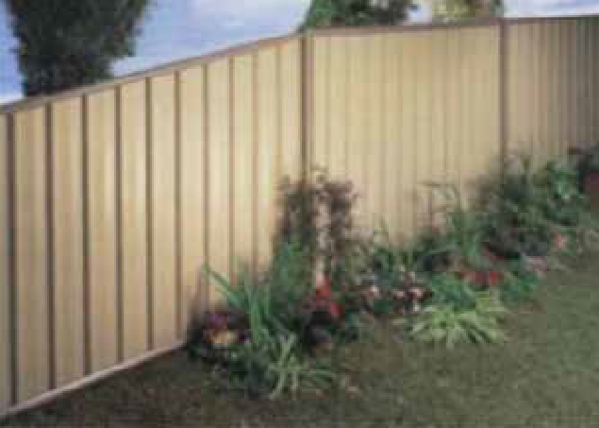
Example 2
- Corrugated iron, or colourbond steel panels (shown) or other solid materials (e.g. used conveyor belting) provide and attractive child resistant fence. Any
necessary supporting horizontal structure should be on the outside of the fence.
- In high winds gates made of solid material may swing open under sustained pressure.
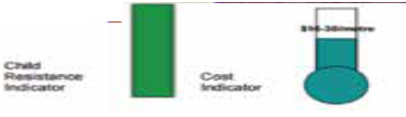

Comments against key criteria
1 | Effectiveness as a child resistant barrier | - This fence makes a very good barrier, and meets the pool standards at a minimum height of 1.2m.  - In high wind gates made of solid material may swing open if latches are not suitably robust.
2 | Potential to injure a child attempting to scale the fence | - The risk of injury is low if top and bottom rails are used to protect the sharp edges as shown.
3 | Robustness, corrosion and wear resistance | - This is a robust and long lasting fence.
4 | Material cost and availability | - Colourbond comes at a higher cost than corrugated iron. Both materials are readily available.
5 | Ease of installation, maintenance requirements | - Installation is straight forward.
6 | Aesthetics and potential to customise | - Cannot see through the fence – whether this is seen as an advantage of disadvantage will depend on what is on the other side.  - The fence may be used to block noise, wind and dust.  - Colourbond comes in a range of colours and styles.

- This fence is of moderate cost, and provides a high level of child resistance. Part of the fence could be constructed using these materials, particularly to screen noise, dust, wind and to provide privacy.

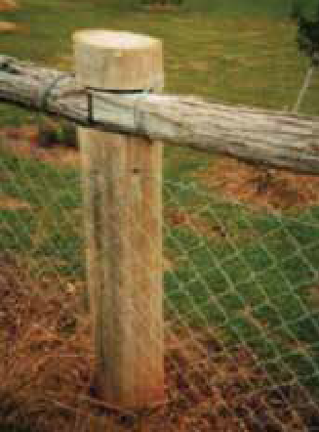
Example 3
- The ‘chain wire’ fence is popular, and used in various configurations. It often accompanies a round hollow section steel frame, or a post and rail arrangement, as shown.
- This material has been at heights of 1.2m and 1.8m.
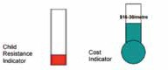

Comments against key criteria
1 | Effectiveness as a child resistant barrier | - This fence does not meet the pool standard, and is easily climbable, due to the large aperture sizes, and the sturdy construction.  - At 1.8m, the fence provides a higher degree of child resistance.
2 | Potential to injure a child attempting to scale the fence | - At 1.8m, there is an increased risk of child injury if they fall in an attempt to climb over the fence.
3 | Robustness, corrosion and wear resistance | - Chain wire is sturdier than chicken wire, and is durable and with a long life.
4 | Material cost and availability | - Chain wire is low cost and is readily available. However, the most common supporting structure is round hollow section galvanised pipe, which is approximately $20 per metre for materials only.  - This cost is naturally higher for a 1.8m fence.
5 | Ease of installation, maintenance requirements | - Installation is straight forward, with low maintenance requirements.
6 | Aesthetics and potential to customise | - A wooden post and top rail is often used to improve the appearance of this kind of fence.

The “chain wire” fence is popular, and used in various configurations. It often accompanies a round hollow section steel frame, or a post and rail arrangement, as shown.
- This material has been used at heights of 1.2m and 1.8m.

VISITORS, CHILDREN AND TRAFFIC

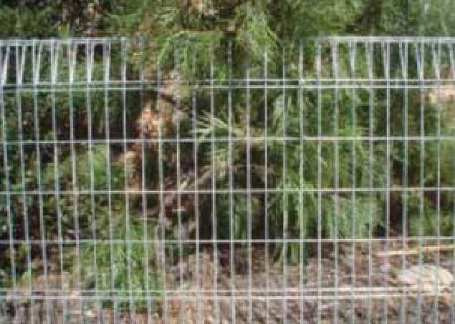
Example 4
- This fence is manufactured in panels 3m wide, by 1.2m high. The wire thickness is 5mm, and is erected by tech screwing the panels to RHS posts.
- This can be seen as an example of any mesh fence, where the horizontal wire supports are close enough together to provide a sturdy climbing support.
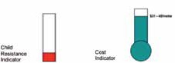

Comments against key criteria
1 | Effectiveness as a child resistant barrier | - This fence is not effective as a child resistant barrier, and is easily climbable.
2 | Potential to injure a child attempting to scale the fence | - The risk of injury is low.
3 | Robustness, corrosion and wear resistance | - This product is galvanised and is therefore long lasting.
4 | Material cost and availability | - The cost is less than similarly designed pool compliant fences.  - Currently this product is widely distributed.
5 | Ease of installation, maintenance requirements | - Installation is straight forward, with low maintenance requirements.
6 | Aesthetics and potential to customise | - It is possible at additional cost to paint or powder coat this product to improve the appearance.

This design is not effective as a child resistant barrier, and is easily climbed.

At all times copyright ownership of these photos must be fully acknowledged to the Australian Centre for Agricultural Health and Safety. Please refer to the University of Sydney’s Disclaimer and Copyright webpage for further clarification. Disclaimer and Copyright webpage: sydney.edu.au/disclaimer.html

TRAFFIC

Vehicles of all sizes including tankers, trucks, cars, utes, 4-wheel drives, quads, tractors and other heavy machinery are common around dairy farms and their

BY LAW

Who has legal responsibility for managing traffic hazards?
- A person conducting a business or undertaking has the primary duty under the WHS Act to ensure, so far as is reasonably practicable, that workers and other persons at the workplace are not exposed to health and safety risks arising from the business or undertaking. This duty includes:
  - Implementing measures to control the risks of persons being injured due to the movement of vehicles or plant at the workplace
  - Ensuring that the workplace and the means of entering and exiting the workplace are without health and safety risks to any person
  - Providing any information, training, instruction or supervision that is necessary to protect all persons from risks to their health and safety arising from work carried out.
- A person with management or control of powered mobile plant must ensure that the risk of powered mobile plant colliding with pedestrians or other plant is controlled so far as is reasonably practicable. If there is a possibility of collision, the plant must have a device that will warn persons who may be at risk from the movement of the plant,
and measures must be taken to eliminate or minimise the risk.
access and use is often near the dairy, buildings or houses where pedestrians and children are present. With larger trucks and machinery, the ability of the operator to see bystanders is diminished, braking distances are greater and manoeuvrability is reduced.
Being hit or run over by these vehicles can be fatal.
The major factor to consider in controlling these risks is how to physically separate vehicles and people.
For a new dairy, traffic and pedestrians can be separated by planning the location of the milking shed, the calf shed, bulk feed silos and bunkers, access tracks, loading and unloading sites and parking for workers and visitors.

For existing dairies, particularly those close to a house, it is important to identify the hazards where people and traffic interact. Discussions with workers, including contractors, may help to identify these hazards more clearly.

Changing the layout of the farm may not always be possible but there will be many ways of reducing the risk of collisions between vehicles and pedestrians.

Best practice
- Develop and implement a traffic management plan that separates people from tractors, trucks, vehicles and mobile plant, especially near the home and dairy
- Install clear directional signage at the farm entrance, speed limits, wearing of PPE (high visibility clothing) and pedestrian/children warning signs
- Fit and maintain reverse mirrors and beepers and proximity sensors to vehicles, and rotating warning lights and reverse beepers to tractors and other mobile plant
- Establish and enforce safety operation procedures and rules such as speed limits and separation distances from mobile plant and machinery
- Wear high visibility reflective clothing that enables operators to see pedestrians more easily, including children
- Have child-proof fencing around houses

VISITORS, CHILDREN AND TRAFFIC
THE GENERAL PRINCIPLES AND EXAMPLES
OF RISK MANAGEMENT FOR TRAFFIC HAZARDS:
Elimination
- Physically separate pedestrians from operating vehicles.
Engineering
- Locate tracks with high traffic and areas for trucks and farm machinery away from the house.
- Design tracks to minimise the need for tankers and trucks to reverse, for example by having pull-alongside access to the vat room, silos and fuel tanks.
- Direct traffic away from hazardous areas such as ditches and overhead powerlines.
- Locate designated parking areas for workers and visitors away from heavy vehicle work areas and traffic zones.
- If needed, provide a bollard protected walkway from the car park to the dairy.
- Protect pedestrians at entrances to buildings and on blind corners with fixed bollards.
- Clearly mark pedestrian walkways, for example with highly visible bollards and/or surface paint.
- Use mirrors and vision panels at doorways to areas where vehicles are present.
- Use temporary gates or barriers to separate vehicles and pedestrians, for example when loading or unloading trucks.
- Ensure traffic areas are well lit.
- Maintain tracks and working areas in good condition.
- Provide strategic speed humps to slow traffic.
- Consider speed limiters on certain vehicles such as quads or side-by-sides.
- Consider quick hitch systems for tractors and machinery that does not require the presence of a second person.
- Have toddler-proof fencing around the house (remember visitors may have young children).

LEARN MORE

General guides for workplace traffic management
safeworkaustralia.gov.au/doc/traffic-management- general-guide
safeworkaustralia.gov.au/doc/information-sheet- traffic-management

TIPS

- Reverse beeper globes can be fitted to the reverse globe socket of cars and 4-wheel drives. Reverse cameras can also be retrofitted to the rear of vehicles and mobile plant.
- Vegetation may need to be removed or cutback so that it doesn’t restrict the vision of operators and pedestrians. Check entrances and exits from the farm onto public roads to ascertain if vegetation is a problem.
- Bollards placed out from the corners of a building will provide a clear space for pedestrians and help protect the building from vehicle damage.
- Reversing tractors and other vehicles into sheds will give operators much clearer vision upon exit.
Safe operation and rules
- Establish speed limits for the farm and around houses and buildings.
- Provide clear directional signage for parking and reporting in.
- Provide clear signage indicating speed limits, entrances for trucks, vehicle operating areas and warning of presence of children.
- Establish exclusion zones for ‘tractor only’ areas such as silage or feed bunkers.
- When unloading a truck ensure the truck driver is in a visible safe zone.
- Have ‘pedestrian only’ areas around entrances, amenities and houses.
- Establish a safe means of communication between machine operators and others.
- Ensure children are supervised if entering a work area, including visitors’ children.
- Wear high visibility and reflective clothing and workwear.

FARM POLICY ON CHILDREN IN THE WORKPLACE

Farm
Purpose | This policy is in place to ensure that children are not at risk on our farm.
Who does it apply to? | Managers, staff, contractors, tenants and visitors.
Consequences of not complying with this policy | Failure to follow the processes outlined in this policy may lead to disciplinary action, dismissal or termination of contract. If any circumstance arises that would make it difficult to comply with this policy, immediately contact:
Policy was last reviewed | Date:

Every area of the farm poses risks for children. Chemicals, water, heights, vehicles, machinery, workshops and livestock are all hazards that can cause serious injuries for kids.

We are absolutely committed to reducing the risk of injury of children on this farm and the following rules apply to all.

- No child is to come onto the work area of the farm without the permission of

- All children must be supervised by an adult at all times.
- When outside to play young children must stay in the safe play area where they can be observed by an adult.
- No child is to be carried on tractors, farm machinery, vehicle trays, trailers, or carried as passengers on Quads.
- All children travelling in vehicles must wear seat belts, or if under 7 years must be in a correctly fitted approved child restraint.
- No child under the age of 16 is authorised to operate a Quad bike.
- No child is to enter the machinery shed, dairy, including yards, feed shed workshop or machine operating area.
On this farm, to reduce the risk of injury to children, the following has been established:
- A safe play area is available at

- Where possible, water hazards have been fenced off or covered
- Access to ladders is prevented
- Hazardous areas have been secured to prevent access by children and unauthorised people
- Our policy on Quad bike use forbids children as operators or passengers
- Keys are removed from vehicles and machinery when they are not in use

VISITORS, CHILDREN AND TRAFFIC

Staff member/contractor acknowledgement
I have received a copy of this policy and have read understood and agree to comply with it.

Name:
Signature: Date:

Remarks or comments:

** File this document in the relevant farm folder and retain for a minimum of two years **

DAIRY SAFETY INDUCTION FOR VISITORS

Business name:

Visitors are welcome to our farm, but it is a workplace and we ask you to co-operate with our health and safety rules.
Please phone:

When you arrive or report to:

who will show you the farm layout and no-go zones and discuss any clothing or protective equipment needed.
In an emergency

Phones are located:
(with emergency numbers beside them)

Fire extinguishers are located:

Children
Children should only be present with the approval of the owner/manager and must not be left unsupervised.
Children are not to play in work areas including:
- the dairy at any time;
- workshops;
- machinery and machinery sheds;
- haysheds and feed bunkers
- near dams or effluent ponds; or
- silos/feed sheds.
Children are not permitted as passengers in or on:
- tractors;
- Quad bikes
- in the back of utes or trucks; or
- any machinery.

Smoking
Make sure all butts are extinguished and disposed of

safely. Take particular care during fire season.

First aid kits are located:

The first aid trained people are:

Emergency assembly points are located:
Note: Smoking is not permitted in any vehicle or building or near hay/haysheds.

Personal health and hygiene
Ensure hands are washed, including children after being near animals and animal manure.
Washing facilities and toilets are located:

Injury and incident reporting
All incidents, accidents and near misses must be reported to the owner/manager.
Incident report forms make up part of the safety management system.
If you don’t report an incident, accident or near miss, the business won’t get the opportunity to look at the situation that caused it. This means that it could happen again with far greater significance!
All injuries or illness must be entered in the injury record book. It is located in:

Vehicles
Vehicles should be parked:

Please abide by speed limits and be aware of children and other pedestrians.

