FARM CHEMICALS

Farm safety guidelines 2
Step-by-step – Setting up safety for 3
use of chemicals on your farm
Self assessment – Add your actions to 4
your Action Plan at the back of this folder
Hazardous chemicals 5
Storage 10
Application 16
Hazardous Chemical Register 18

FARM SAFETY GUIDELINES

Chemicals are used on dairy farms for cleaning, treating animals, controlling pests, applying as fertilisers and adding to feed.
Other chemicals on farms include fuels, oils and various gases. Asbestos is also present on many farms. Exposure to workers and others can occur during transport, storage, use and disposal of these chemicals.
Many chemicals have the potential to cause harm to human health and safety. Acute health effects include headaches, nausea or vomiting and skin injuries.
Chronic health effects can include asthma, dermatitis, nerve damage or cancer. Chemicals that are flammable, corrosive, explosive, chemically reactive or oxidising
may also harm workers with more immediate effects such as burns.

Each hazardous chemical has a Safety Data Sheet (SDS) with information and instructions on how it can be stored, handled and used safely in the workplace.

There is a significant amount of regulation around management of hazardous chemicals on dairy farms. This topic focuses on the impact of chemicals on people. Use the resources in your Farm Safety Manual to ensure that you are managing a safe workplace and fulfilling your legal obligations.

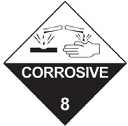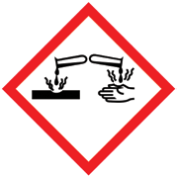

STEP-BY-STEP – SETTING UP SAFETY FOR USE OF CHEMICALS ON YOUR FARM


1. Getting started

Read through this information pack
3. Setting up your policy, processes and paperwork
Set up a Register of Hazardous Chemicals with each SDS attached.
Complete the farm chemicals Safety Self-Assessment (traffic lights) page.
Set up a storage Manifest
(if a Manifest is required).
Make a list of things to do and set a date to have each thing completed in the Action Plan.

Read through the information quickly again.
Set up relevant Standard Operating Procedures (including use of PPE) for tasks involving hazardous chemicals.
Pick a topic to discuss with staff or family
at your next workplace meeting (you should have at least one safety topic each meeting).
Put a copy of the Register and SOPs with the documents you use to induct new staff or relevant contractors.
2. Assessing the risks around use of chemicals on your farm
Task someone with making a list of all the chemicals used on the farm and where they are located.
Go through the arrangements you now have in place with workers or family at your next
workplace meeting.
Sleep well – job well done
Obtain the Safety Data Sheet (SDS) for each chemical and review the classification, storage, handling and use guidelines

Make any required structural changes you have identified and buy any gear or Personal Protective Equipment (PPE) needed.

Arrange any ChemCert or other training needed.

Find out if you have contractors who are better equipped to use these chemicals.

Resources in this section
- Information about hazardous chemicals on dairy farms and legal obligations
- Safety Self-Assessment for managing hazardous chemicals

Template for Hazardous Chemical Register.
Information and templates provided in this folder are also available at thepeopleindairy.org.au/farm-safety
You can edit the templates to suit your farm.

SELF ASSESSMENT – ADD YOUR ACTIONS TO YOUR ACTION PLAN AT THE BACK OF THIS FOLDER

For farm chemicals | Poor practice  Address these areas immediately! | Improving safety practice  There is still work to be done | Great  safety practice  Monitor and review  to continually improve
Hazardous chemicals identified and in Register | Not done | Not complete or up-to-date | Register complete and up to date
Dangerous goods identified and storage manifest completed (if required) | Not done | Not complete or up-to-date | Manifest (if required) complete and  up to date
Safety Data Sheets | Not obtained | Not up-to-date or easily available for all chemicals | All up to date and easily available where chemicals are used
Asbestos audit and management plan | Not done | Audit done but plan not implemented | Audit done, plan fully implemented
Chemical storage areas including fuels and chemicals in use | No particular areas set up | Some separate, purpose-built | All purpose-built and compliant with regulations
Warning signage | None | Some in place | All in place and correct for storage and use areas
Access by children and unauthorised people | Easily could happen | Some restriction | All restricted
Farm chemicals application | No reference to SDS | Some according to SDS | All according to SDS
Accredited training for farm chemical use | None | Some | Must be completed (with evidence) before being allowed to do that work
Farm inductions for new staff | Farm chemicals not included | General warnings | Farm chemicals and relevant safety processes identified
Personal Protective Equipment (as specified by the SDS) | None, or not in working order | Some available, not always used | Available, in good condition and working order, always used
Restriction of eating, drinking, smoking while handling chemicals | None | Sometimes | Always
Supervision to ensure safety during work | None | Sometimes | Always
Records of induction and training | Not kept | Some | Complete and up to date
Reporting accidents and incidents | No process set up | Process set up, not used by all | Process is used by all workers
Follow-up | None | Limited review and action | All issues acted on, including notifications required by law
Emergency response plans | None | Only for one type of emergency | In place for all emergencies

HAZARDOUS CHEMICALS

Exposure to workers and others
can occur during transport, storage, decanting, mixing, use, cleaning

and disposal of hazardous chemicals.
Critical factors to consider in all aspects of safe chemical handling are understanding what you need to use, and how to use it.
Advice from qualified experts is important to determine if chemicals are needed (e.g. factory field officers or chemical suppliers for dairy detergents, agronomists for pasture and crop treatments and veterinary officers for animal treatments).
The Safety Data Sheet (SDS) is a document that provides detailed information about each hazardous chemical. By following the information and instructions in the SDS, all chemicals can be stored, handled and used safely in the workplace.
Chemical classification
The first step in managing risks associated with chemicals is to identify all the chemicals that are used, handled, stored or generated on the farm and determine if they are classified as hazardous chemicals.
Each agricultural and veterinary chemical product available has been assessed to determine if it can cause harm to human health and safety. This involves the identification and evaluation of the physical properties of the chemical, along with its health effects.
If it is assessed to be hazardous, the chemical is then classified according to an international system. It is the classification of a hazardous chemical that determines what information is communicated on the label and the Safety Data Sheet.

Chemical hazards
In relation to chemicals, a hazard is a set of inherent properties of the substance, mixture, article or process that may cause adverse effects to people, animals or the environment.
There are two broad types of hazards associated with chemicals which may present an immediate or long term injury or illness to people. These are:
- Health hazards – These are properties of a chemical that have the potential to cause adverse health effects. Exposure usually occurs through inhalation, skin contact or ingestion. Adverse health effects can be acute
(short term) or chronic (long term). Typical acute health effects include headaches, nausea or vomiting and skin irritation. Chronic health effects include asthma, dermatitis, nerve damage or cancer.

- Physicochemical hazards (often known as Dangerous Goods) – These are physical or chemical properties of the substance, mixture or article that pose risks to workers other than health risks. They arise through inappropriate handling or use and can often result
in injury to people and/or damage to property. Examples of physicochemical hazards include flammable, corrosive, explosive, chemically reactive and oxidising chemicals.
Many chemicals have both health and physicochemical hazards.

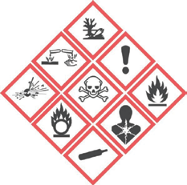

TIP

How can you tell if a chemical is classed as hazardous?
Always consult the product label and relevant SDS. If a chemical is hazardous it must have a Safety Data Sheet (SDS) and the manufacturer or supplier must provide you with a copy. Section 2 of the SDS will tell you if the chemical is hazardous.
Other indications are that the label of the product includes:
- Diamond-shaped warning pictograms (as below).
- Signal words Danger or Warning.
- Hazard or precautionary statements such as Toxic if swallowed and Wear eye protection.
- Risk or safety phrases such as Harmful if swallowed
and Keep out of the reach of children.

A risk assessment is not mandatory for hazardous chemicals under the WHS Regulations (except in specific situations, for example when working with asbestos).
However, a risk assessment is the best way to:
- Identify which workers are at risk of exposure
- Determine what sources and processes are causing that risk
- Identify what kind of control measures should be implemented
- Check the effectiveness of existing control measures.
Where the hazards and associated risks are well- known and have well established and accepted control measures, it may not be necessary to undertake a risk
assessment, for example, where there are a small number of chemicals in a workplace and the hazards and risks are well understood.
Documenting risk assessments is not mandatory, but may help when reviewing where improvements can be made and risks controlled more effectively.

LEARN MORE

Guidance on for Managing Risks of Hazardous Chemicals in the Workplace
safeworkaustralia.gov.au/chemicals#codeguides
Specific guidance including for risk assessments for hazardous chemicals: see compliance codes for hazardous chemicals in your jurisdiction, see
safeworkaustralia.gov.au/whs-authorities-contact- information
Dangerous goods, including signage information
worksafe.vic.gov.au/resources/code-practice- storage-and-handling-dangerous-goods

BY LAW

By law, the person conducting the business in any workplace has serious obligations to manage risks associated with hazardous chemicals.
Work Health and Safety regulations require that you must:
  - Identify reasonably foreseeable hazards that could give rise to the risk
  - Eliminate the risk so far as is reasonably practicable
  - If it is not reasonably practicable to eliminate the risk, minimise it by implementing control measures in accordance with the hierarchy of control
  - Maintain the implemented control measures so that they remain effective
  - Consult, so far as is reasonably practicable, with workers who are (or are likely to be) directly affected by the chemicals.
The regulations require that you must:
  - Prepare a register of all hazardous chemicals
on the farm and keep it up-to-date
  - Ensure that the current Safety Data Sheet (SDS) for each hazardous chemical is readily accessible by workers
  - Prepare a manifest of all Schedule 11 chemicals kept above threshold volumes and keep it up to date
The regulations also require you to:
  - Store chemicals as per the SDS, with appropriate signage
  - Maintain correct labelling
  - Have a spill containment system in place if there is the risk of a spill or leak
  - Ensure that equipment is available for use in an emergency
  - Provide relevant information, training, instruction and supervision to workers
  - Provide appropriate personal protective equipment (PPE).
Note: there is also a regulation that requires workers, so far as they are reasonably able, to wear the PPE in accordance with the
information, training and reasonable instruction that they have received.
By law, you are responsible for all the people who use or may be affected by hazardous chemicals on your farm.

Best practice
- Consider whether there are safe non-chemical alternatives. For example:
  - Use of pressure washers instead of chlorine chemicals for algae control on concrete
  - Mechanical removal of weeds
  - Biological control of pests
- If a chemical is to be used, select a chemical or application that will achieve the same result with less risk to users, others and the environment. For example:
  - Substituting a highly flammable liquid with one that is less or non-flammable or combustible
  - Using a product in paste or pellet form rather than as dust or powder
  - Purchasing liquids in ready-to-use formulations and container sizes instead of decanting from large containers and mixing
- Separate people from the chemicals by distance or barriers to prevent or minimize exposure. For example:
  - Using closed systems such as those available for cleaning vats and milk lines
  - Isolating chemical application in one room with access restricted to properly protected personnel
  - Using a cabined tractor fitted with charcoal filters when applying chemicals to pastures or crops
- Set up purpose-built storage sites that, for example: separate chemicals, contain spills, provide ventilation (see Section below on Storage).
- Set up and regularly review the documents required by law:
  - Obtain the current Safety Data Sheet for each chemical
  - Establish and maintain a register of the hazardous chemicals, with the SDS for each chemical attached
  - Establish a storage manifest for Schedule 11 chemicals where the storage quantities exceed the prescribed limits
  - (See the Sections below on SDS, Register and Manifest for more details)
- Routinely review chemical use and storage and dispose of unwanted chemicals and containers
- Ensure each chemical is stored and used according to the instructions in the SDS
- Develop safe work procedures for hazardous chemicals (e.g. use of acids and alkalis)
- Restrict use of hazardous chemicals to authorised and trained people only
- Clean up spills immediately
- Always consult the SDS for the required Personal Protective Equipment (PPE) when handling chemicals
- Establish emergency response plans and provide training in the emergency responses

TIP

A pest control program should always consider prevention, effectiveness of the control, impact on the environment and the impact on the user, others and the consumer. If a chemical is decided as the best means of treatment, then the safest chemical should be selected.
All managers, share farmers and supervisors should consider undertaking Integrated Pest Management awareness training and ChemCert training or equivalent.
For more information on Integrated Pest Management see:
epa.nsw.gov.au/pesticides/

TIP

Encourage all workers to report any incidents and ‘near misses’ relating to farm chemicals. This enables you to investigate hazards before they lead to health or safety problems. A positive, responsive attitude by supervisors and managers is essential to have this type of reporting become part of the safety culture on the farm.

The Safety Data Sheet (SDS)
The SDS provides detailed information about a hazardous chemical, including:
- The identity of the chemical product and its ingredients
- The hazards of the chemical including health, physical and environmental hazards
- Physical properties of the chemical, like boiling point, flash point and incompatibilities with other chemicals
- Safe handling and storage procedures for the chemical, including required PPE
- What to do in the event of an emergency or spill
- First aid information, and
- Transport information.
The SDS will tell you how to eliminate or reduce the risks associated with the use of the hazardous chemical.
The SDS is available from the product manufacturer or supplier. Most can be downloaded. Manufacturers and suppliers are required to up-date each SDS at least every 5 years, so check periodically to ensure you have the most up-to-date SDS on hand.
By law, you must have the current SDS for each hazardous chemical readily accessible by workers. This can be hard copy or electronic if workers have ready access to a computer at work.

TIP

Use the Safety Data Sheet for each chemical when inducting or refreshing workers who will be using the chemical. In most cases the SDS will contain more detailed and up-to-date information about a hazardous chemical than appears on the label.

Register of hazardous chemicals
Work Health and Safety regulations require that a person conducting a business or undertaking must ensure that
a register of hazardous chemicals at the workplace is prepared and kept up-to-date.
All hazardous chemicals that are stored, handled or used on the farm must be listed on the register except where they are in-transit or consumer products:
- Hazardous chemicals are considered to be in-transit if they are not used in the workplace and are not kept at the workplace for more than five consecutive days.
- Consumer products are those that are packed primarily for use by a household consumer and are used in a manner consistent with normal household use. Note: chemicals not classified as hazardous chemicals do not require SDSs to be kept and do not need be included in this register.
The register must be readily accessible by workers involved in using, handling or storing hazardous chemicals and to anyone else who is likely to be affected by a hazardous chemical at the workplace. Registers may be kept electronically provided workers have ready access to a computer. Otherwise a hard copy should be kept in the location where chemicals are mostly used.
If you do not already have a Register of Hazardous Chemicals, download the template on The People in Dairy website or use the hard copy in your Farm Safety Manual.

LEARN MORE

Understanding Safety Data Sheets for Hazardous Chemicals
safeworkaustralia.gov.au/doc/understanding-safety- data-sheets-hazardous-chemicals

Manifest of Schedule 11 hazardous chemicals

BY LAW

PROVIDING INFORMATION, TRAINING, INSTRUCTION AND SUPERVISION
Work Health and Safety regulations require that a person conducting a business or undertaking must ensure that information, training and instruction provided to a worker is suitable and adequate having regard to:
- The nature of the work carried out by the worker
- The nature of the risks associated with the work at the time the information, training or instruction is provided, and
- The control measures implemented.

You must also provide any supervision necessary to protect workers from health and safety risks arising from the work at the workplace, if the worker:
- Uses, handles, generates or stores a hazardous chemical
- Operates, tests, maintains, repairs or decommissions a storage or handling system for a hazardous chemical, or
- Is likely to be exposed to a hazardous chemical.
Work Health and Safety regulations require that a storage manifest is required where hazardous chemicals that are dangerous goods are present at the workplace and where their quantities exceed specified threshold amounts.
The manifest is intended primarily for emergency services personnel to use when they are responding to an emergency situation at the workplace.
A manifest is different from the register of hazardous chemicals. It is required to contain additional information including the hazard classes and categories of the hazardous chemicals and details of the type, size and locations of containers present at the workplace.
If you have Schedule 11 hazardous chemicals in quantities that exceed the thresholds, there is an example on The People in Dairy safety site to help you prepare your own manifest.

LEARN MORE

For further information about requirements relating to manifests, refer to the Managing risks of hazardous chemicals in the workplace Code of Practice. See:
safeworkaustralia.gov.au/chemicals#codeguide
safeworkaustralia.gov.au/registers-manifests-and- placards

Creating Standard Operating Procedures and Policies

Dairy Passport aims to create positive, safe, sustainable workplaces through enabling capability development and adoption of standard operating procedures and policies in dairy farm business.

LEARN MORE

ChemCert is an industry-based non-profit organisation provides face-to-face and online training, up-skilling and industry accreditation for users of Agricultural and Veterinary (AgVet) chemicals.
For more information on legislation about AgVet chemicals and relevant training, see:
chemcert.com.au/about-chemcert
It allows dairy farms to manage all the members of their farm team via an online platform and link them to the key tasks, across multiple farm properties, that need to be undertaken on-farm.
Dairy Passport is customisable to each farm business, with information easily displayed via Dashboards of
on-farm tasks and Standard Operating Procedures (SOPs) and Policies that need to be undertaken, aligned to each farm team member.
Dairy specific templates are available to assist farmers getting started in setting up their systems or enhance
their current on-farm practices. Visit dairypassport.com.au
to register.
Examples of policies and procedures provided in the Farm Safety Manual are available on Dairy Passport.
Visit dairypassport.com.au to register.

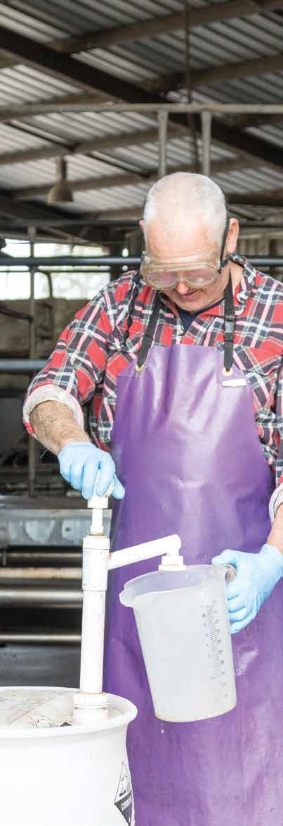
Source: Dairy Australia
10

STORAGE

BY LAW

PERSONAL PROTECTIVE EQUIPMENT (PPE)
Work Health and Safety regulations require that if personal protective equipment (PPE) is to be used at the workplace, the person conducting the business or undertaking must ensure that the equipment is:
- Selected to minimise risk to health and safety
- Suitable for the nature of the work and any hazard associated with the work
- A suitable size and fit and reasonably comfortable for the person wearing it
- Maintained, repaired or replaced so it continues to minimise the risk
- Used or worn by the worker, so far as is reasonably practicable.
Regulations also require that a worker must, so far as reasonably able, wear the PPE in accordance with any information, training or reasonable instruction.

TIP

PPE is usually made to an Australian Standard.
Ensure the correct PPE is selected by referring to the SDS and cross checking. Certain chemicals often prescribe particular PPE (e.g. glove types).

Correct storage of chemicals reduces the potential of exposure to workers, visitors, children, animals and the environment. Locked storage prevents both unauthorised access and theft.
Health and safety, Agvet and environmental regulations require chemicals to be stored according to the relevant SDSs. Most dairy farms require a number of different chemical storage areas, including for chemicals that must be refrigerated. Purpose-built facilities should be constructed or purchased for each of these areas.
When determining how chemicals are to be stored, consideration should be given to:
- The type of chemical
- The information provided on the label and in the SDS
- The classification of the chemical i.e. dangerous good and/or hazardous substance
- The container size and total volumes and or weight in storage and in use
- The application methods, e.g. manual decanting or closed dosage systems
- Access for contractors for supply, connection and removal of empty containers, e.g. vat and milk line cleaning chemicals, LPG gas bottles
- The exposure of the site and methods to prevent unauthorised and child access
Chemicals in use such as acids and alkalis should be isolated to prevent unauthorised, incidental or child access and should include separation of acids and alkalis, barriers that prevent hand or finger access, spill containment within the barriers, and ease of access to move drums in and out of storage.
Best practice

Elimination of the need for storage
- Consider having relevant chemicals delivered the day they are to be used.
- If a contractor is used, for example to spray pastures, request that they bring and take away the chemicals, thus eliminating any storage requirements on farm.
- Dispose of all unwanted and out-of-date chemicals.

TIP

Disposal of unwanted chemicals and empty containers may be possible through your local shire or by a privately engaged contractor.
A national programme called ChemClear will arrange pick up under certain conditions.
For further information go to
chemclear.org.au/chemical-disposal/
Empty containers can be disposed of through the drumMUSTER program. For conditions and procedures go to: drummuster.com.au

Engineering
- Construct storage facilities for chemicals with the following features:
  - Materials that are non-combustible and
non-porous, including floors, walls and shelves
  - Containment for spills (bunding) and an interceptor trap
  - Good ventilation
  - Protection from moisture
  - Sufficient room for maximum quantities to be stored, including bulk containers, 1000 litre shuttles and pallet loads
  - Security and signage
  - An appropriate spill clean-up kit
  - A fire extinguisher
  - Locations for SDS, emergency documents and PPE
  - An emergency deluge shower, hand and eye wash facility.

Administrative Controls

TIP

Chemicals requiring refrigeration must not be stored with food stuffs or drinking water.
Have a separate, labelled fridge (bar type fridge for small quantities) for storage of vaccines and animal treatments and lock to prevent child and unauthorised access.
Sign clearly as ‘Chemical Storage No Food Allowed’.
- Have all SDSs available at the storage facility (and protected from contamination)
- Separate incompatible chemicals such as acids and alkalis (check the SDS to determine which ones)
- Separate chemicals from food stuffs
- Store chemicals in original correctly labelled containers
– NEVER in drink containers
- Check all containers for leaks
- Put up relevant signs - ‘Chemical storage’ and additional signs according to what is stored and the quantities stored
- Follow procedures for disposal of empty chemical containers, e.g., triple rinse, use DrumMuster service

TIP

Keeping chemicals cool in extreme hot weather
Summer can be a tough time for farm chemicals. Heat can reduce the effectiveness of products and UV radiation can degrade plastics, possibly rendering containers unsafe.
For very hot weather:
- Check labels and SDSs and move heat- sensitive products into cooler storage areas
- Fit lockable screens so you can open exterior doors and windows to help improve airflow.
- Install an extractor fan to draw in cooler air, in addition to rooftop whirlybirds
- Always keep chemicals out of direct sunlight, or if containers can’t be moved, cover them with a tarpaulin as a temporary solution
Single-skin sheds (such as shipping containers) heat up very quickly. A permanent solution is to install a temperature-controlled unit with insulation construction, to control extremes of heat and cold year-round.

Personal Protective Equipment (PPE)
- Use the PPE required by the SDS when handling chemicals in storage or at application
- To avoid contamination of PPE, locate it adjacent to the chemical storage facility or in a secure plastic tub within the store

LEARN MORE

ChemCert guide for storage of hazardous chemicals: chemcert.com.au/pdfs/Resources/ChemCert
%20guide%20to%20storing%20hazardous%20 chemicals.pdf
Bunding guidelines for storage facilities epa.sa.gov.au/files/47717_guide_bunding.pdf

TIP

Purpose built chemical storage facilities are commercially available including from:
instaco.com.au/utility-sheds/chemical-storage- sheds/
shadycharacters.com.au/product/chem-shed
greataussieshadesheds.com.au/chemical-sheds/

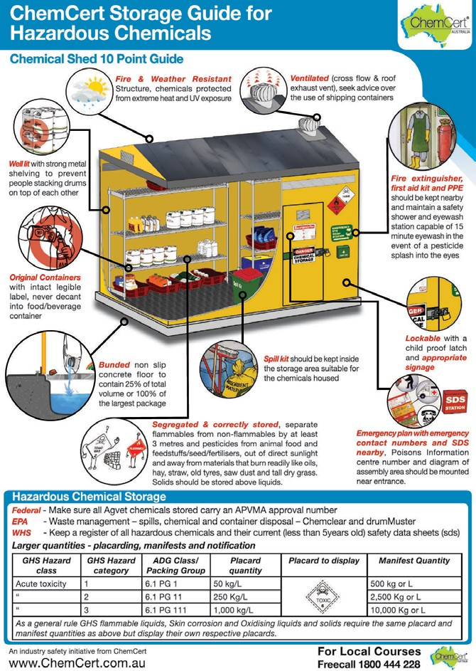

Farm chemical storage area checklist

TIP

Incorrectly labelled or unlabelled containers
If you find a container that does not have a label or is incorrectly labelled, action must be taken to correctly label the container.
- Containers that have had chemicals transferred into them (decanted) in the workplace, and containers of chemical wastes need to be labelled correctly.
- If the contents of the container are not known, this should be clearly marked on the container, for example, ‘Caution - do not use: unknown substance’. Such a container should be stored in isolation until its contents can be identified and, if it is then found to be hazardous, the
container is appropriately labelled. If the contents cannot be identified, they should be disposed
of in accordance with relevant local waste management requirements.
Is the storage area properly constructed?
Is it in a lockable area? (preventing access by children and unauthorised persons)
Is there sufficient bunding to retain a leak or spill? (25% of total volume stored)
Is it resistant to fire?
Is there protection from moisture?
Is it adequately ventilated?
Is there sufficient light? (natural or artificial)
Are there clear warning signs posted on the outside? Are there materials available to control spills?
Are all chemicals stored in their original containers?
Do all containers have clear and legible labels?
Are the Safety Data Sheets (SDSs) available nearby?
Are all chemicals stored in accordance with label instructions and the SDS?
Are incompatible materials (e.g. flammables and poisons) stored away from each other?
Are food and drink prohibited in the area?
Is a dedicated refrigerator available for chemicals that require refrigeration?
Are appropriate fire extinguishers located nearby?
Is there an emergency shower and eye wash located nearby?
Are emergency contact numbers nearby? (Poisons information hotline 13 11 26, emergency services)

Bulk fuels

TIP

Using drums for fuel storage
- Engage a contractor to deliver drums
- Use a trolley to move drums
- Do not undertake splash filling of 200 litre fuel drums
- Ensure earthing of small containers if decanting
- Do not cut or weld empty fuel drums
Diesel and unleaded petrol (ULP) must be located away from sources of ignition, with ULP at least 15 metres away. (If ULP and diesel tanks are next to each other, they are considered to be one storage and requirements for the ULP will apply). The surrounds should be free of
combustible material including grass, trees and timber for a radius of at least 3 metres. A foam extinguisher close to the storage area is advisable.
Bulk fuel storage should have spill containment, be protected from vehicle damage and have secure and solid footings. Tanks should have a routine engineering assessment. Overhead tanks need step access with hand rails and platforms that are compliant with AS 1657.

TIP

Using gas bottles
- After fitting LPG bottles, test for leaks with soapy water spray
- Ensure gas regulators are regularly inspected and replaced/repaired if damaged
- Inspect hoses regularly for damage, perishing and wear
- Fit flash-back arrestors to the bottle end of oxy and acetylene hoses
- Remove out-of-date LPG bottles (both 45kg and 9kg) from service
To prevent unauthorised access, lock hoses or locate in a lockable open air compound.

LPG and compressed gas bottles
Gas bottles should be stored and transported in a vertical position to allow venting. Empty and full bottles that are not in use should be placed in racks in secure areas. Oxygen (oxidising compressed gas) and acetylene flammable-compressed gas must be stored away from ignition sources and combustible material in an external or ventilated area, with signage showing ‘No smoking or open flames’.
Bottles in use should be chained vertically to walls or posts and protected from damage by vehicles or
livestock. When moving bottles, strap them upright in a purpose-built trolley.

APPLICATION

Tasks which involve applications of chemicals on dairy farms include:
- Cleaning of milking machinery and vats
- Treating algae on concrete
- Teat spraying
- Drenching
- Vaccinations
- Spraying of pasture and crops
- Spot spraying of weeds
All these tasks potentially expose the user and others to harmful substances.
Depending on the chemicals, exposure can have an immediate effect (such as burns caused by a violent reaction between acids and alkalis) or health effects which occur soon after exposure (such as skin irritations) or in the longer term (such as development of cancer with, for example, organophosphates).
When applying any chemical always consider how best to reduce the exposure to people, livestock and the environment. If existing application equipment, skills or PPE are not sufficient, consider engaging a specialist contractor to undertake the application.

Best practice

Engineering controls
- Isolate the chemicals by using closed systems wherever this is possible. Examples include closed dosage and chemical transfer systems and enclosed decanting bottles.
- Use cabined tractors with charcoal filters to apply pasture and crop chemicals

Administrative Controls
- Provide training and supervision for all workers involved in chemical application
- Secure all chemicals during transport
- Calculate the amount of chemical required accurately, to avoid the need to dispose of unused sprays
- Ensure the mixing site has adequate ventilation
- Have at least 20 litres of water available for washing at the mixing and application sites
- Ensure no drinking, eating or smoking during mixing and application
- Ensure unauthorised persons are not present during mixing and application
- Ensure all chemicals in use cannot be accessed by children or unauthorised persons
- Maintain application equipment in good condition as per the manufacturer’s guidelines. Always use gloves when cleaning spray nozzles
- If using a Quad bike, ute, or Side-by-Side to spray or spot spray, ensure lids and applicators are secured to avoid splashing and accidental operation. Wash down after use
- Follow EPA and SDS recommendations for disposal of excess spray and rinsate
- Follow re-entry periods or withholding periods prescribed on the label or SDS after application
- Use PPE if entry to the application area must occur before the re-entry period has expired
- Ensure hands are washed before going to the toilet eating and/or smoking
- Develop an emergency response plan for transport, mixing and application

Personal Protective Equipment (PPE)
- Obtain and use relevant PPE as per the SDS,but remember it only protects the person wearing it
- Maintain PPE in good condition
20 Wash any overalls or clothing separate from other clothing

TIP

When selecting chemical gloves consider the task as well as the chemical. Some tasks such as cleaning nozzles require feel, other tasks may potentially damage or rip the glove.
There are many options. Discuss the type of gloves with a safety equipment supplier, or see:
ansell.com/-/media/projects/ansell/website/ pdf/single-use/microflex/microflex-brand-page/ microflex-93-850-how-to-choose-the-right-glove- guide-1.ashx?rev=6f0c774d0ba04ab0a271105fe9fe 46e4

Asbestos

LEARN MORE

Rinsate is produced as a result of rinsing drums or cleaning application equipment. The EPA(NSW) provide recommendations on managing rinsate:
epa.nsw.gov.au/resources/ pesticides/120100PestRinsate.pdf
Managing leftover chemicals
dpipwe.tas.gov.au/Documents/Guidelines%20for%20 Managing%20Leftover%20Chemicals_Feb2014.pdf
Washdown and disposal pit
dpipwe.tas.gov.au/agriculture/agvet-chemicals/ codes-of-practice-guidelines-and-information- sheets/guidelines/washdown-area-and-disposal- pit-diagram
Asbestos may be present on dairy farms, for example in cement sheeting that lines vat rooms, as lagging around old hot water pipes or behind old power boards. Asbestos can also be found in other buildings and houses.
Asbestos becomes a health risk when its fibres are released into the air and breathed in. Breathing in asbestos fibres can cause asbestosis, lung cancer and mesothelioma.
If you suspect asbestos is on your farm you must manage
the risk of exposure:
  - Engage a licensed contractor to undertake an asbestos audit of all facilities on the farm (this includes old/ unused houses and sheds) and develop an asbestos management plan
  - Implement and document actions outlined in the plan

LEARN MORE

For more information about asbestos see: safeworkaustralia.gov.au/asbestos

HAZARDOUS CHEMICAL REGISTER

A Hazardous Chemical Register is a list of all hazardous chemicals used, handled or stored on your farm.
You must keep the current Safety Data Sheets (SDSs) with this register and make sure it is accessible to workers. The SDS will tell you if the chemical is hazardous, and how to use and manage it safely. The supplier of your chemicals should provide a SDS on request.
Contact the manufacturer or supplier for a copy of the SDS or for more details. Many companies also provide SDSs online.

Chemical name | Manufacturer including Australian contact details | SDS issue date (must be <5 years) | Maximum quantity held on site* | Comments

HAZARDOUS CHEMICAL REGISTER CONTINUED

Chemical name | Manufacturer including Australian contact details | SDS issue date (must be <5 years) | Maximum quantity held on site* | Comments

HAZARDOUS CHEMICAL REGISTER CONTINUED

Chemical name | Manufacturer including Australian contact details | SDS issue date (must be <5 years) | Maximum quantity held on site* | Comments

