MANUAL HANDLING

Farm safety guidelines 2
Step-by-step – Setting up safety 3
for manual handling on your farm
Self assessment – Add your actions to 4
your Action Plan at the back of this folder
Manual handling 5
Milking 9
Lifting and carrying, including calves, 11
drums, buckets and bags. Working with awkward postures.
Hazardous Manual Task 13
Identification Worksheet

FARM SAFETY GUIDELINES

Workers’ compensation data for dairy farming shows 1 in 5 claims involving more than 5 days off work are due to body stresses that result in musculoskeletal disorders. These serious injuries cause suffering for the people involved, economic losses for the farm and increased workers’ compensation premiums and a poor employment reputation for the industry.
Workers on dairy farms do a wide variety of manual tasks that involve lifting, lowering, pushing, pulling, carrying, holding or restraining things or animals. These tasks have

the potential to be hazardous if, for example, they involve postures that are awkward or sustained, forces that are high, sudden or repeated, movements that are repetitive, or exposure to vibration.
Musculoskeletal disorders resulting from hazardous tasks include back injuries, sprains and strains, joint and bone injuries or degeneration, nerve injuries or compression, hernias and chronic pain.
As an employer or person conducting a business
on the farm you have a legal responsibility to manage risk to health and safety associated with all hazardous manual tasks. Use these resources to ensure that you comply with this requirement.

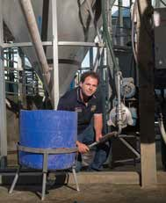Dairy Safely Home Safely - Ideas Bank

Reducing the need to lift buckets of calf milk on Nankita Dairy farm

Nankita Dairy Farm at Mount Compass have installed a nifty system for collecting and transporting calf milk which reduces the need to lift heavy
buckets full of milk and tip them into calf feeders.
Step 1 – Milk collected into test buckets (from cows undergoing antibody treatment) is tipped into a blow proper this is the only step that uses buckets
Step 2 – Milk from the hopper is pumped up into a refrigerated calf milk storage vat
Step 3 – If more calf milk is required there is a line directly to the calf milk storage fat from the main milk vat
Step 4 – Calf milk is pumped from the calf milk storage vat to another vat on the back of the farm ute which is then driven to the calf shed
Step 5 – The calf milk is pumped from the vat on the unit directly into the calf feeders
This system has minimised the risk of injury to the calf rearers’ wrists, shoulders and back.

The hopper is connected to the calf milk storage vat via a pipe with a small pump

MANUAL HANDLING

STEP-BY-STEP – SETTING UP SAFETY FOR MANUAL HANDLING ON YOUR FARM


1. Getting started

Read through this information pack
3. Setting up your policy, processes and paperwork
Set up relevant Standard Operating Procedures for tasks involving manual handling.
Complete the manual handling Safety Self-Assessment (traffic lights) page.
Put a copy of the SOPs with the documents you use to induct new staff or relevant contractors.
Make a list of things to do and set a date to have each thing completed in the Action Plan.

Read through the information quickly again.
Go through the arrangements you now have in place with workers or family at your next
workplace meeting.
Pick a topic to discuss with staff or family
at your next workplace meeting (you should have at least one safety topic each meeting).
Sleep well – job well done
2. Assessing the manual handling risks on your farm
Task someone with making a list of the manual handling tasks on the farm. Ask them to take pictures of some of the tasks.

Do a risk assessment of each task using the Risk Assessment Checklist and plan the control changes needed.

Make any required structural changes you have identified and buy any gear needed.

Arrange any training needed.

Find out if you have contractors who can
do the work you need that involves some of these
tasks. (e.g. supply and fitting of detergent drums).

Resources in this section
- Information about manual handling tasks on dairy farms and legal obligations
- Safety Self-Assessment for manual handling

Hazardous Manual Task Identification Worksheet
Information and templates provided in this folder are also available at thepeopleindairy.org.au/farm-safety
You can edit the templates to suit your farm.

SELF ASSESSMENT – ADD YOUR ACTIONS TO YOUR ACTION PLAN AT THE BACK OF THIS FOLDER

For manual handling | Poor practice  Address these areas immediately! | Improving safety practice  There is still work to be done | Great  safety practice  Monitor and review  to continually improve
Worker involvement and feedback about manual tasks | Not involved | Some information and discussion | Fully involved in decisions and developing procedures
Hazardous manual tasks identified, and risk assessments conducted e.g. for milking, calf rearing, feeding, workshop work, handling chemicals and tractor operation | Not done | Some done | All tasks assessed
Bulk handling e.g. for feed, calf milk and fertilisers | Not used at all | In some areas | In all areas
Mechanical aids such as trollies, hoists, carts, pallet jacks and frontend loaders used for lifting and moving heavy and awkward objects | None, or not used | Some available, sometimes used | Available and always used
Dairy design for workers to milk comfortably (height of platform or pit, equipment location, ACRs, matting) | Not considered | Some features | Well designed for milker comfort
Other work areas designed for worker comfort (reducing the need to overreach, twist or bend continuously and keeping everything within reach or within the shoulder-hip area.) | Not considered | Some areas well set up | All areas well set up
Ergonomic seating on tractors and mobile plant | None | Some | All
Work procedures for relevant tasks | Not developed | Limited development and review | All developed and regularly reviewed
Implementation of work procedures | Never | Sometimes | Always
Scheduling to ensure adequate breaks, job rotation and prevention of fatigue | Not done | Limited development and review | All developed and regularly reviewed
Training in safe manual handling practices including setting up the work area, using aids, safe lifting techniques and managing the body? | Not done | Some training but not covering all aspects | All workers trained in all aspects needed
Records of induction and training | Not kept | Some | Complete and up to date
Reporting injuries | No process set up | Process set up, not used by all | Process is used by all workers
Follow-up | None | Limited review and action | All issues acted on, including notifications required by law

MANUAL HANDLING

MANUAL HANDLING

Work Health and Safety regulations define a hazardous manual task as one that requires a person to lift, lower, push, pull, carry or otherwise move, hold or restrain any person, animal or thing, involving one or more of the following:

TIPS

As a guide, the National Model Code of Practice for Hazardous Manual Tasks,October 2018 says:
- A repetitive task is one that occurs more than twice a minute
- A sustained task is one where the posture or force is held for more than 30 seconds at a time
- Bending the back or neck more than 20 degrees forwards or sideways, or 5 degrees backwards, in a repetitive or sustained task can be hazardous
- A task of long duration is one that occurs continually for more than 30 minutes at a time, or more than 2 hours in total over a whole shift
- Repetitive or sustained force (e.g. pulling a calf or carrying buckets)
- High or sudden force (e.g. lifting a large drum or calf into the back of a vehicle; physically handling calfs)
- Repetitive movement (e.g. attaching milking cups)
- Sustained or awkward posture (e.g. bending over for cups-on in a shallow pit or at a low rotary platform)
- Exposure to vibration (e.g. operating a tractor or quad bike over rough ground).
These tasks occur in many work areas on the farm, including the feed shed, the workshop and the chemical store, the calf shed, gateways and yards and especially in the dairy when milking.

BY LAW

WHS Regulations require that a person conducting a business or undertaking must manage risks to health and safety relating to a musculoskeletal disorder associated with a hazardous manual task. They must:
- Identify reasonably foreseeable hazards that could give rise to the risk
- Eliminate the risk so far as is reasonably practicable
- If it is not reasonably practicable to eliminate the risk – minimise the risk so far as is reasonably practicable by implementing control measures in accordance with the hierarchy of control
- Maintain the implemented control measure so that it remains effective
- Review, and if necessary revise, risk control measures to maintain, so far as is reasonably practicable, a work environment that is without risks to health and safety.
By law, you are responsible for all the people who perform manual tasks on your farm, including all permanent and casual milkers and calf-rearers.

Musculoskeletal disorders that occur from hazardous tasks include:
- Back injuries, including damage to the muscles, tendons, ligaments, spinal discs, nerves, joints and bones
- Sprains and strains of muscles, ligaments and tendons
- Joint and bone injuries or degeneration, including injuries to the shoulder, elbow, wrist, hip, knee, ankle, hands and feet
- Nerve injuries or compression (e.g. carpal tunnel syndrome)
- Muscular and vascular disorders that result from hand-arm vibration
- Soft tissue hernias
- Chronic pain.
These injuries occur either by gradual wear and tear to joints, ligaments, muscles and inter-vertebral discs
caused by repeated or continuous use of the same body parts (including static body positions), or by sudden damage caused by strenuous activity or unexpected movements such as when loads that are being handled suddenly move or change position.
There can also be a combination of gradual wear and tear and sudden damage. A body tissue that has been weakened by cumulative damage may be vulnerable to sudden injury by a lower force. For example, injuries to the back may appear to be sudden but are often a result of many years of wear and tear, making the discs between the vertebrae weak and prone to rupture.

The most common hazardous manual tasks on dairy farms are associated with bending, lifting and carrying (especially calves, drums, buckets and bags) and working with awkward postures, including milking and operating machinery. Milking is particularly significant as it often involves a range of hazardous manual tasks and is the dominant activity on the farm.

TIP

Ask about discomfort
Workers can provide valuable information about discomfort, muscular aches and pains that can signal potential hazards. For example, ask workers to identify tasks that:
- Are difficult to do
(or appear harder than they should be)
- Are very tiring
(muscle fatigue reduces work capacity)
- Are awkward or dangerous
(for example, difficulty controlling loads)
- Cause discomfort that persists, or re-occurs the next day, or continues after rostered days off
The risk of injury can be significantly reduced by setting up the physical aspects of the workplace and the work processes to minimise the requirements for bending, twisting or loading and lifting heavy items. During long shifts the tasks should be changed around to give the muscles a break.

Best practice
- Use the National Model Code of Practice* and associated checklists to identify and manage the risks of hazardous manual tasks in the workplace
- Involve workers in the process, especially to identify potential manual handling hazards
- Control the risks, for example:

TIP

Think ergonomics (human factors)
Ergonomics:
- explores the interaction between people and the work environment
- is the process of designing or arranging workplaces, products and systems so that they fit the people who use them
- consider the workers individual size, strength, skill, speed, sensory abilities and sometimes attitudes.
Small things can make a big difference when they involve equipment that is used many times. For example:
- Seating on tractors and other mobile plant ergonomically designed with settings to suit each user
- Clusters that are not too heavy
- Well balanced, light weight tools that minimise wrist twist, with easy-to-use triggers and minimal vibration.
  - (Re)design the workplace to minimise manual handling hazards
  - Use mechanical/lifting aids where possible
  - Ensure that workers are trained in correct techniques for manual handling jobs, including asking for help
- Monitor the effectiveness of those controls

LEARN MORE

*Codes of Practice can help identify and manage manual handling risks in the workplace:
- Use Appendix D Hazard identification worksheet in Hazardous Manual Tasks Code of Practice, Safe Work Australia, October 2018
safeworkaustralia.gov.au/system/files/ documents/1905/model-cop-hazardous-manual- tasks.pdf
This checklist is useful to identify hazards associated with current and new tasks on the farm.

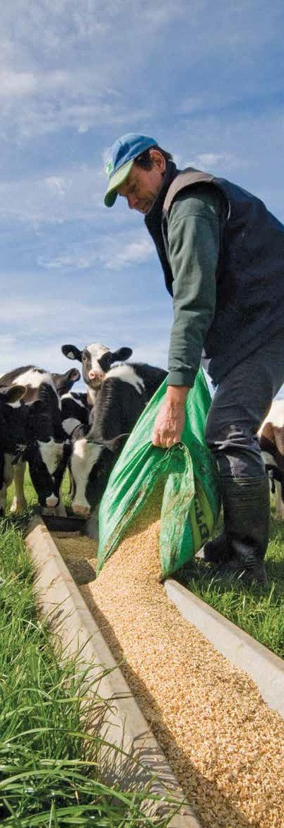
MANUAL HANDLING
Farm Safety Manual 2021 7

TIP

Well-designed work areas can significantly reduce the chances of injuries. For example:
- Keep things you use most often in easy-to-reach places that minimises twisting.
- Reduce carrying distances.
- Avoid the need to open doors or gates while carrying loads.

LEARN MORE

Visit:
- Preventing manual handling injuries on farms
dairynz.co.nz/media/1273377/handling-injuries- farms.pdf
- Ergonomics and manual handling aghealth.sydney.edu.au/wp-content/ uploads/2019/05/6.-Ergonomics.pdf

THE RISK MANAGEMENT PROCESS FOR MANUAL TASKS (SAFE WORK AUSTRALIA 2018)

Risk management process for manual tasks
ASSESS
IDENTIFY
CONSULT
CONSULT

WHAT IS THE MANUAL TASK?
Using the body to lift, lower, push. Pull, carry or otherwise move, hold or restrain any person, animal or thing.
IS THE MANUAL TASK HAZARDOUS?
Application of force: | Posture: | Movement: | Exposure to vibration
- repetitive | - sustained | - repetitive
- sustained | - awkward
- high
- sudden

WHAT IS THE RISK OF MSD?
- How often and how long are specific postures, movements or forces performed or held?
- What is the duration of the task?
- Does the task involve high or sudden force?
- Does the task involve vibration?
WHAT IS THE SOURCE OF RISK?
Work area design and layout | Systems of work | Nature, size, weight and number of persons, animals or things handled | Work environment

- Is the task necessary?
- Can the source of risk (work area layout, environment etc.) be changed?
- Can mechanical aids be used to perform the task?
- What training is needed to support the control measures?

- When the control measure is no longer effective
- Before a change at the workplace that is likely to give rise to a new or different health and safety risk that the control measure may not effectively control
- If the new hazard or risk is identified
- If the results of consultation indicate that a review is necessary, or
- If a health and safety representative at the workplace requests a review.

Source: safeworkaustralia.gov.au/system/files/documents/1905/model-cop-hazardous-manual-tasks.pdf (Appendix C page 59)
REVIEW
CONTROL
CONSULT
CONSULT

MANUAL HANDLING

MILKING

Handling milking clusters is the most frequent and repetitive manual task on a dairy
farm and can result in injury, particularly if milkers are bent in awkward positions (like attaching or removing milking clusters in a shallow pit or at a low rotary platform).

The obvious hazard is a mismatch between worker height and pit depth or rotary height.
Automatic Cup Removers (ACRs) remove the need for someone to work in the cups-off position but pulling down on the ACR chord to prepare the cluster for milking can require substantial effort and being repetitive can increase fatigue and potentially result in injury. To avoid this, vacuum relief valves should be fitted to the ACRs.
Other milking related situations where injuries can occur include:
- Twisting or bending to reach control pads, herd test flasks or other frequently used items that cannot be placed directly in front of the milker
- Milking when the pace is too high, where stress leads to tightened muscles and fatigue
- Working on concrete for long periods, which can increase muscle fatigue
- Jumping from heights such as rails and platforms which can lead to shock loading of the back.
Robotic or automatic milking eliminates the risks associated with milking and this may be a consideration for some businesses when considering new dairies.

TIP

Set up the dairy to reduce the need to bend, twist or load.
- Keep the work in front, between shoulder and mid-thigh height. This helps people to work in a
position that keeps the natural lumbar curve in the lower back.
- Move the feet rather than twisting the back.
- Have the load in front and close to the body.
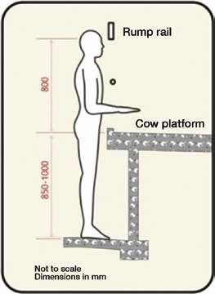
Recommended heights for milking Source: CowTime Quicknotes

Best practice

Engineering
- Design or alter cups-on/off area so it adjusts to suit the worker’s height.
- Locate idle clusters on brackets and jetters at a height that reduces bending and reaching.
- Fit ACRs wherever practicable.
- Retrofit vacuum release valves on ACR rams.
- Locate controls or frequently used items in front of the worker, or a step away to avoid twisting.
- Always consider milker fatigue when selecting ‘higher weight’ clusters.
- Use teat spray wands with a long nozzle to reduce the need to bend and reach.
- Locate herd test sample flasks in a position that minimises bending.
- Use a herd test sample sorting table that reduces reaching (angled towards worker) and bending.
- Set colostrum buckets on wheels.
- Use rubber matting in the pit or cups on, cups off position to reduce fatigue (for individual mats, ensure they have bevelled edges to reduce the risk of tripping).

Administrative Controls
- Consult with workers, observe and review workers’ cups-on technique to reduce repetitive overreaching.
- Rotate jobs to reduce repetitious manual handling tasks, including rotating between cups-on and cups- off positions.
- Ensure the pace of milking is set to match the worker (especially when herd testing).
- Do warm up exercises and stretching before milking.

Personal Protective Equipment (PPE)
- Wear cushioned rubber boots.

TIP

Milking stretches
Top level sports people wouldn’t dream of skipping their pre- and post- activity stretches!
Milking can also be a strenuous activity and tailored stretches to prepare the body for milking and cool down afterwards should be a part of everyone’s routine.

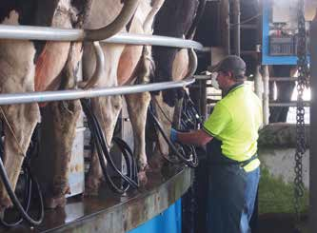
Work positions that keep the natural curve of the lower back minimise back injuries.
Source: Dairy Australia

LEARN MORE

Visit:
- Manual handling in the dairy
worksafe.govt.nz/topic-and-industry/agriculture/ working-with-animals/staying-safe-in-and- around-farm-dairies

MANUAL HANDLING

LIFTING AND CARRYING, INCLUDING CALVES, DRUMS, BUCKETS AND BAGS. WORKING WITH AWKWARD POSTURES.

Lifting and carrying objects can involve high, sustained, repetitive or sudden forces. For example, lifting and stacking feed or fertiliser bags, carrying milk or water in buckets, lifting drums to pour out contents, lifting coils of wire and lifting calves on
to a vehicle are all common tasks that contribute to the risk of lower-back pain, injury and other musculoskeletal disorders.
Alternatives to lifting and carrying heavy items include, for example: using trolleys and hoists, or purchasing
in either smaller package sizes or in bulk and moving pallets with a front-end loader.
There is no prescribed maximum weight that a worker should lift, as manual handling often involves a combination of risks. The worksheets in Appendices of the Hazardous Manual Tasks Code of Practice, Safe Work Australia, October 2018 provides a good guide to assess tasks.
Features of loads that influence the risks include:
- A bulky load makes it hard to keep the weight close to the body and increases the load on the spine and joints.
- A lighter weight that is held away from the body needs the same effort to handle as a heavy one held close.
- Jerking or moving a load quickly uses more force than just carrying the load.
- Extra force and awkward postures may occur if loads are jammed or stuck, uneven in weight or unstable (such as liquids or sacks of pellets), greasy, hot or very cold, contain hazardous substances, have inadequate handles or sharp edges, or obstruct a forward view.
- And the risk of injury is increased if the work is conducted on slippery or uneven surfaces.
Animals pose particular manual handling problems, such as how to maintain a grip on the animal and how to counter unpredictable movements. How much help the animal can give, whether it cooperates, and how much
pain it might experience also affect the way each animal should be handled. In some situations, special techniques are required (See Farm Safety Manual topic on Working with Livestock).
Moving new-born calves is a common task on dairy farms. Calf trailers should be used rather than vehicles. The trailer height should allow the worker to place the calf with minimum effort, without obstruction and without twisting. The trailer should be located as close to the calf as possible. A slide-out ramp can be used to walk older calves on and off.

TIP

General recommendations for lifting objects:
- Balance your body’s weight equally over both feet.
- Step close to the load.
- Think about the best place to grip the load and the best type of grip to use.
- Bend your knees and use your legs, not your back.
- Keep the load in front of you, as close to your body as possible.
- Apply force gradually, after testing the weight.
- Lift smoothly, rather than using sudden exertion.
- To change direction while moving, take a step in the new direction rather than twisting your body.
- Pace the work if it goes on for a long time, take small breaks often.
- For slightly heavier loads obtain assistance and team lift using the same technique.
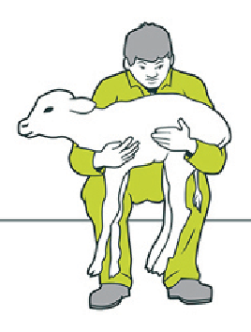

TIP

Lifting new-born calves causes many back injuries.
If you have to lift a new born calf, use your legs and keep the back as straight as possible.
Squat down beside the calf, pull it in close with one arm around the front and the other around the hind legs, hold the calf firmly then straighten the knees to lift.
Correct calf-lifting technique Source: Worksafe NZ

Best practice

Elimination
- Use bulk handling equipment and methods for hay, grain, feed and fertiliser.
- Obtain items on pallets.

Substitution
- Get items in smaller packaging, e.g. smaller packs of steel posts, smaller trays for herd test flasks.

Engineering
- Use pallet jacks in locations not accessible with the front-end loader.
- Use ute or truck mounted hoists.
- Use bag and drum trolleys and carts for shifting loads.
- Use drum pourers for chemical or oil transfer.
- Set up content extraction systems for drums of chemicals to reduce lifting and tipping.
- Have ramps or level ground to access the dairy for delivery of chemical drums and pickups of herd test crates.
- Design calf trailers at a height for easy placement of calves.
- Install ramps for accessing trailers and vehicle.
- Set up bulk transfer systems for calf milk (pumps, hoses and holding vat-tank).
- Attach handles to items, or place them in a carrier with handles.
- Source chemicals and substances in ready to dose packaging.
- Maintain yards in good condition and ensure gates swing freely.
- Ensure good vehicle suspension.
- For tractors and other mobile plant, install ergonomically designed operator seats on suspension systems with well-maintained adjustments for individual operators.

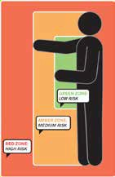
Administrative Controls
- Store light items on shelving above shoulder height, heavy items at ground level for access by trollies and medium weight items at mid-thigh.
- Provide training in how to identify hazardous manual handling tasks, the use of manual handling aids and safer lifting and team lifting techniques.

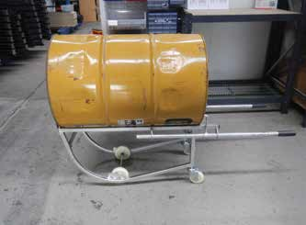
A drum trolley makes moving and dispensing from drums much easier. Source: Andrew Sullivan

20 Balance the load when carrying buckets, e.g. 15 litres in each hand.
- Plan regular rest breaks to reduce holding awkward positions for too long.
- Rotate jobs to reduce repetitious manual handling tasks.
- Do warm up exercises and stretching.

Personal Protective Equipment (PPE)
- Use gloves for grip and to protect hands from sharp edges.
- Wear boots with good grip and reinforced toes (in case a load is dropped).

Source: WorkSafe Victoria
– A Safer Way to Lift and lower objects

MANUAL HANDLING

HAZARDOUS MANUAL TASK IDENTIFICATION WORKSHEET (SAFE WORK AUSTRALIA)

Work area:

Health and safety representative and workers taking part:

Management representative: Date:

Does the task have any of the characteristics of a hazardous manual task? (Tick any of the following that apply.)






Task
Repetitive or High or sudden Sustained or sustained force force awkward postures
Repetitive movement
Exposure to vibration

If you ticked any boxes for a particular task, you should do a risk assessment of that task including the Discomfort Survey in Appendix E, Appendix F – Risk Assessment Worksheet in the Hazardous Manual Tasks Code of Practice, Safe Work Australia, October 2018 to do this in a comprehensive way.
These are available at safeworkaustralia.gov.au/system/files/documents/1905/model-cop-hazardous-manual-tasks.pdf

